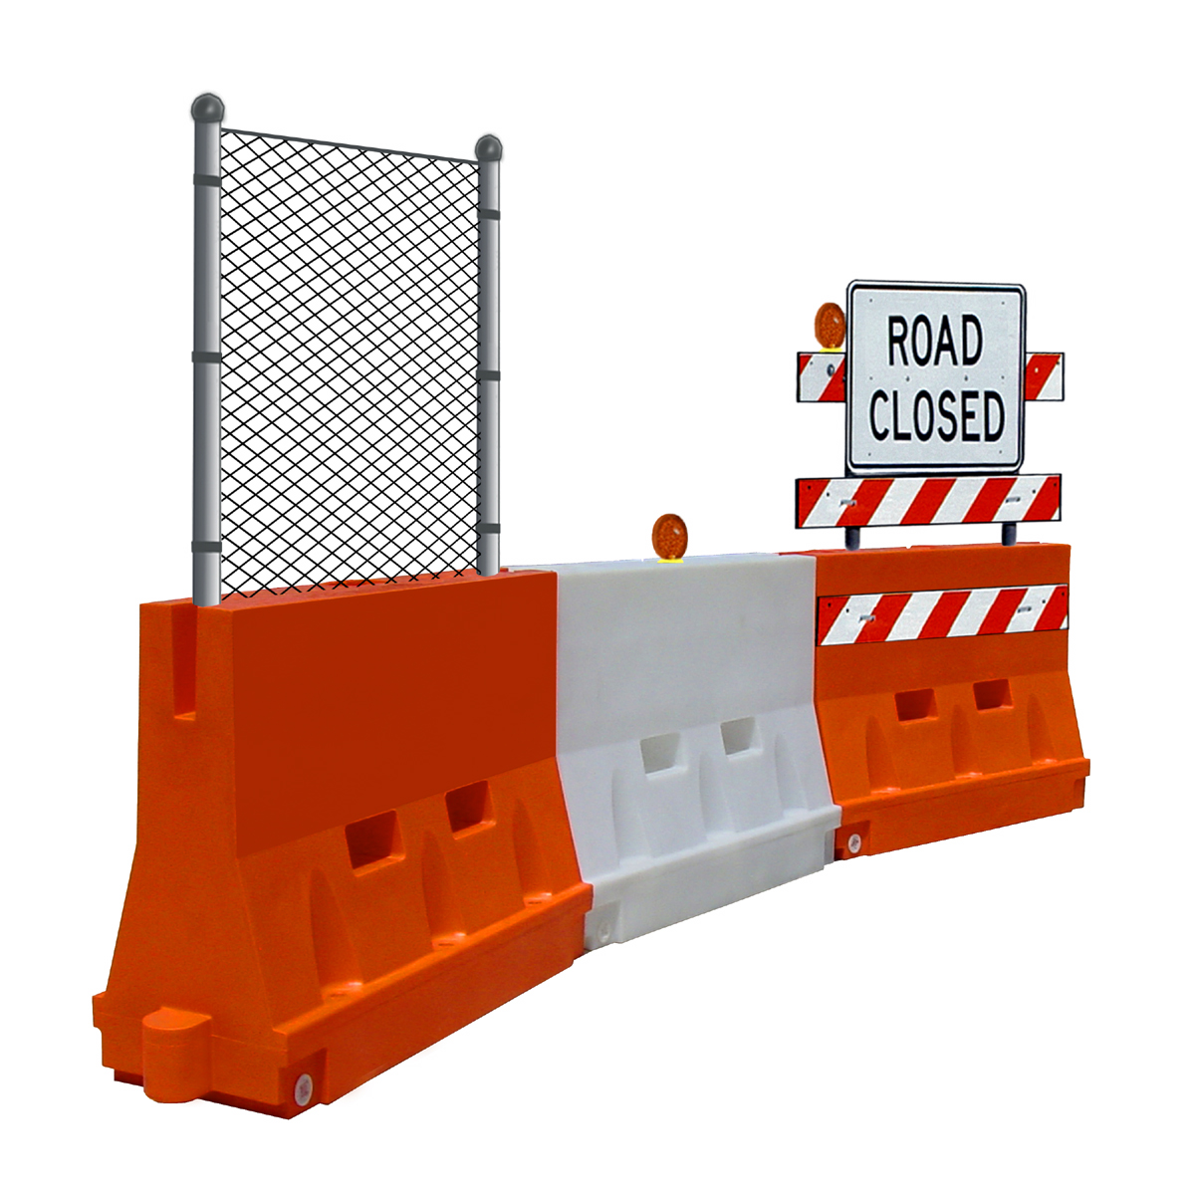 |  |  | 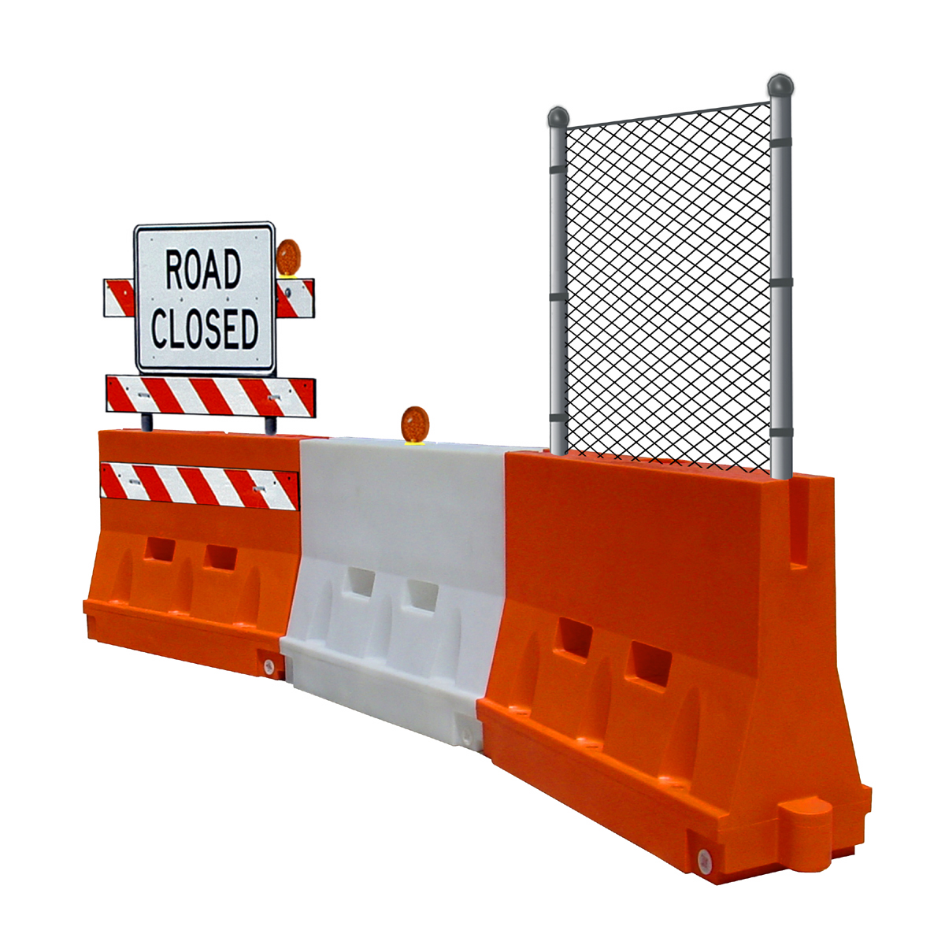
 | 900 Patterson Drive  Bloomsburg, PA 17815 | Phone (570) 380-2856  Fax (570) 380-2859
 | www.yodock.com
Government Price List
Contract # GS07F0094W
Effective November 16, 2009

SIN # | Model # | Description | GSA
246-35-5-5  246-43 | Yodock 2001 | 46" tall plastic barricade - orange, natural, and custom colors | $ 326.31
246-35-5-5  246-43 | Yodock 2001M | 32" tall plastic barricade - orange, natural, and custom colors | $ 228.57
246-35-5-5  246-43 | Yodock 2001 w/fencing | 46” tall plastic barricade w/fencing – orange, natural, and custom colors | $ 431.08
246-35-5-5  246-43 | Yodock 2001M w/fencing | 32” tall plastic barricade w/fencing – orange, natural, and custom colors | $ 333.15
246-35-5-5  246-43 | Yodock 2001SL | 18" tall plastic barricade- orange, natural, and custom colors | $ 124.00
246-35-5  246-43 | Yodock APC w/Tape | 8” tall airport barricade with tape | $ 120.52
246-35-5  246-43 | Yodock APC w/o Tape | 8” tall airport barricade without tape | $ 101.02
246-35-5  246-43 | Yodock 2001 CP | 46” tall plastic barricade corner piece – orange, natural, and custom colors | $ 257.84
246-35-5  246-43 | Yodock 2001M CP | 32” tall plastic barricade corner piece – orange, natural, and custom colors | $ 211.48
246-35-5 | Yodock EMR 10 | 10' trailer without barricades | $ 4,736.21
246-35-5 | Yodock EMR 10-2001 (8) | 10' trailer with 8- 2001 barricades | $ 7,520.81
246-35-5 | Yodock EMR 10-2001M (18) | 10' trailer with 18- 2001M barricades | $ 9,125.74
246-35-5 | Yodock EMR 14 | 14' trailer without barricades | $ 6,446.54
246-35-5 | Yodock EMR 14-2001 (12) | 14' trailer with 12-2001 barricades | $ 10,624.35
246-35-5 | Yodock EMR 14-2001M (24) | 14' trailer with 24-2001M barricades | $ 12,299.50
246-35-5 | Yodock EMR 18 | 18' trailer without barricades | $ 8,459.17
246-35-5 | Yodock EMR 18-2001 (16) | 18' trailer with 16-2001 barricades | $ 14,030.20
246-35-5 | Yodock EMR 18-2001M (36) | 18' trailer with 36-2001M barriers | $ 17,239.10
246-35-5  246-43 | T3Kit | 3 panels, reflective sheeting, posts and hardware for Type 3 Barricade | $ 225.92

