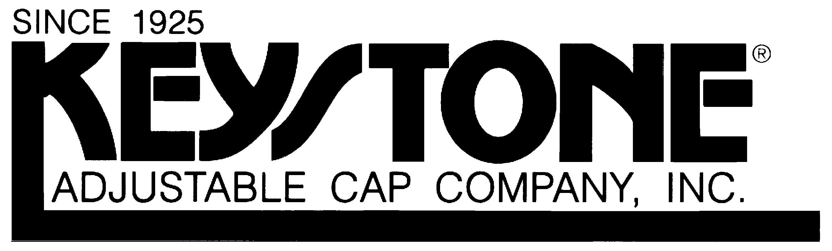
1591 Hylton Road

Pennsauken, NJ 08110

General Services Administration
Federal Supply Schedule
Authorized Federal Supply Schedule Catalog/Price List

Schedule 0539: Title: FSC Group 73, Food Service Equipment

FSC Class: 7320

Contract Number: GS07F-0518M

Contract Period: September 15, 2002 through September 14, 2017

Contractor: Keystone Adjustable Cap Company, Inc.
1591 Hylton Road
Pennsauken, NJ 08110
Phone: (856) 663-5740
Fax: (856) 663-6075

Contractor’s Administrative Source:
Keystone Adjustable Cap Company, Inc.
1591 Hylton Road
Pennsauken, NJ 08110
Phone: (856) 663-5740
Fax: (856) 663-6075

Business Type: Small, Manufacturer

Information for Ordering Activities:

1a. Table of Awarded Special Item Numbers (SIN’s)

  - Food Service Items

1b. Identification of the lowest priced model number and unit price:

302-41 Flair Top Cotton Chef Hat, Elastic Closure (CH-07-E) $ 0.85

2. Maximum Order: $ 300,000 per SIN, $ 300,000 per order
If the “best value” selection places your order over the Maximum Order, identified in the catalog/price list, you have the opportunity to obtain a better schedule contract price. Before placing your order, contact the above mentioned contractor for a better price. The contractor may:
- offer a new price for this requirement
- offer the lowest price available under this contract , or
- decline the order.

A delivery order that exceeds the maximum order may be placed under the Schedule contract in accordance with FAR 8,404.

3. Minimum Order: None

4. Geographic Coverage: 50 States, Washington, DC and Puerto Rico

5. Point of Production:
Keystone Adjustable Cap Company, Inc.
1591 Hylton Road
Pennsauken, NJ 08110
Phone: (856) 663-5740
Fax: (856) 663-6075

6. Basic Discount: Keystone Adjustable Cap Company, Inc. Price List, effective July 15, 2008, les 10%.

7. Quantity Discount: None.

8. Prompt Payment Terms: 1%, 10 days, net 30 days

9. Type of Government Purchase Cards Accepted: VISA, MasterCard

10. Foreign Items: None

11a. Time of delivery after receipt of Order (ARO): 7 days ARO

11b. Expedited delivery: 5 days ARO if in stock with prior telephone verification

11c. Urgent Requirement: Clause I-FSS-140-B of the contract applies. Agencies can
Contact contractor’s representative to possibly affect a faster delivery.

12. FOB Point: Origin

13. Ordering Address:
Keystone Adjustable Cap Company, Inc.
1591 Hylton Road
Pennsauken, NJ 08110
Phone: (856) 663-5740
Fax: (856) 663-6075

14. Payment Address.
Keystone Adjustable Cap Company, Inc.
1591 Hylton Road
Pennsauken, NJ 08110
Phone: (856) 663-5740
Fax: (856) 663-6075

15. Warranty Provisions: Standard Commercial Warranty applies. 15% restocking fee.

16-23. N/A

24: Year 2000 (Y2K) Compliant

25: Environmental Attributes (e.g. Recycling content, energy efficient and reduced pollutants):

26. Duns Number: 00-229-1532
Register in SAM

