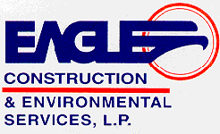



Schedule for Environmental Services
Federal Supply Group: 899 Class: F999
SIN: 899-3 Environmental Occupational Training Services
SIN: 899-8 Remediation Services

The Competitive Edge

Eagle Construction and Environmental Services, L.P. is the leading full-service environmental contractor providing a full schedule of environmental and remediation services. Our diverse team of managers and technical specialists bring new ideas and management styles to build upon our commitment of providing customer friendly, quality environmental services in the industry. We provide support to local, state and national commercial, industrial and government clients. Our services include emergency response, environmental remediation, large facility/plant salvage and demolition, radioactive materials removal, health and safety, training, hazardous and non-hazardous waste management, and environmental consulting.

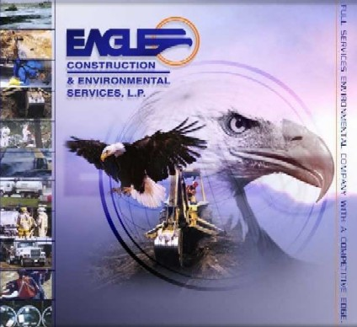

CORPORATE OVERVIEW

Since 1981, Eagle has developed into the leading full-service environmental company capable of performing a full schedule of services throughout the United States. Eagle has served the environmental industry with practical environmental solutions by offering comprehensive services in numerous areas of expertise. Some of Eagle’s services include environmental restoration, hazardous and non-hazardous remediation, excavation, transportation and disposal, large facility/plant salvage and demolition, biological remediation, sludge and soil stabilization, site closures, and radiological remediation and decontamination services. Eagle has structured its business organization to center its focus on environmental remediation, facility decommissioning and emergency services with the full compliment of in house resources to efficiently support tasks of any magnitude.
Eagle has maintained time-tested procedures and policies for resourcing large-scale remediation projects simultaneously throughout the United States. These procedures allow flexibility and responsiveness while maintaining cost effectiveness and efficiency and will provide a value-added benefit, through experience, on all tasks performed.
Eagle provides a comprehensive scope of capabilities and experience through professional judgment. Eagle has earned an unequaled reputation in the industry for providing cost-effective solutions acting in a safe, professional, and successful manner while limiting liability and expense for our clients.
Eagle’s full time staff of over 400 personnel retain their own expertise in various fields such as emergency planning and response, project management, remedial investigations, waste management, design and implementation, and regulatory interfacing. A strong corps of managers support Eagle’s field staff of foremen, craftsmen, and operators. Eagle’s philosophy of teamwork and accountability and proven ability to integrate the numerous professional disciplines within the company have resulted in a group of highly motivated individuals whose focus results in successful completion of projects and customer satisfaction. The high level of training and experience of our staff in the full range of emergency and environmental services assures our clients of thorough consideration in the critical elements of each response activity ensuring that all tasks are completed in the safest manner possible.
Our attitude and dedication to providing quality services has demonstrated Eagle’s capabilities in providing professional personnel and the right equipment necessary for providing a wide array of services.
Joe Walraven, Eagle's founder, president and CEO, reflects that commitment with continual reinvestment in equipment, quality personnel, and extensive on - going training. It is how he and his team have built the Texas-headquartered company to a highly respected organization with $50 million + in annual sales and assets in excess of $25 million.
Eagle is headquartered in Eastland, TX, with 6 other offices strategically located throughout Texas and the eastern United States. Eagle’s branch locations cover the Lone Star State from Houston, San Antonio, Eastland and Fort Worth, Texas; Louisiana and the south east coastal region from Gonzales, Louisiana; and America’s Heartland from Harriman, Tennessee and Findlay, Ohio.
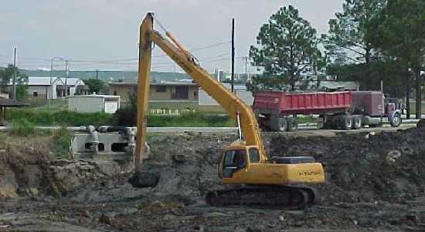

DIVISIONS

The Eagle organization is made up of multiple divisions that work in harmony to provide the best overall experience on each and every project. The seamless integration of Eagle’s 6 divisions provides Eagle with the in-house resources to provide a more effective and efficient response organization. The most valuable resources contained within the Eagle organization are our experienced and diverse staff of employees working at Eagle making up these divisions. These integrated in house resources are unmatched by any of our competitors.

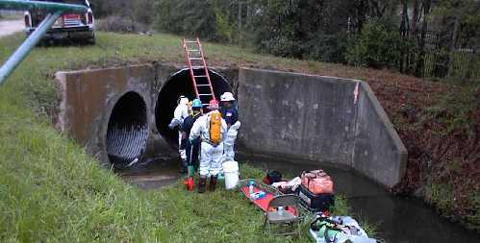

REMEDIATION and FIELD SERVICES
SIN 899-8 Remediation Services

Eagle’s Remediation Division has served the environmental industry with practical environmental solutions by offering comprehensive services in numerous areas of expertise. Eagle possesses extensive capabilities and experience in the remediation of contaminated and environmentally impaired sites, as well as cleanup, handling and disposal of hazardous materials. The key advantage Eagle offers is our ability to provide an integrated approach to environmental management as well as our ability to handle all project phases from investigation through design to final cleanup. The result is enhanced control and the ability to streamline costs by employing one provider to manage and execute all phases of a project. Eagle will provide the full range of methods and technologies supporting activities necessary for Remediation Services including dismantling, demolition, or removal of improvements. Remediation shall conform to environmental permits, decision document requirements or other legal requirements.

Eagle’s Remediation and Construction Services Include:

- Turnkey Remediation (RCRA, Hazardous, Nuclear, & Non-hazardous)
- Hazardous Materials Remediation
- Hazardous/Non-Hazardous Waste Stabilization Technologies
- Confined Space Entry Work
- Facility and plant decommissioning and demolition
- Facility and plant equipment salvage
- Sludge Removal and Solidification
- Post Disaster Decontamination, Restoration and Demolition
- Bio-remediation
- Chemical Lab-Packing and Disposal
- Incinerator Installation and Demolition
- Mechanical Installations and Plant Maintenance
- Wastewater Treatment Plant Installation
- Soil Vapor Extraction System Installation
- Tank De-watering and Cleaning
- Industrial and Commercial Demolition
- Railroad Right-of-Way Maintenance
- General Civil Construction
- Pond Closure and Capping
- Waste Water Treatment
- Landfill Construction and Closure
- Filter Press and Centrifuge
- Lead Abatement
- Aquifer Restoration
- Facility/Site Closure
- Oil Spill Cleanup and Refinery Services
- Asbestos Management
- Post-Closure Monitoring and Maintenance
- Explosives Disposal and Demolition
- Soil Stabilization, Excavation and Remediation
- General Construction Services
- Standby Rescue Services (Confined Space & High Angle)
- Underground Utility Construction

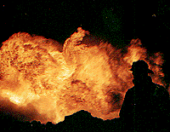

EMERGENCY RESPONSE

Sin 899-8 Remediation Services

Eagle’s Emergency Services Division is comprised of some of the most experienced and capable managers, foreman and technicians in the industry. Eagle’s Emergency Services Division is capable of performing spill response activities involving the abatement of present or impending danger through the identification and assessment of hazards presented by unknown substances or explosive chemicals or materials. Eagle has a proven record of quickly and safely controlling and removing spills or releases of oil, hazardous and reactive materials and other substances. From a small oil spill to a terrorist event involving potential Weapons of Mass Destruction, Eagle is capable and ready to respond.
Since the tragedy of 9-11, a heightened sense of awareness has spread across America concerning the fear of terrorism on American soil and the presence of Weapons of Mass Destruction (WMDs). The Homeland of America and its governing bodies have been forced to take actions in order to not only prevent future terrorist attacks, but be prepared to respond to them. Eagle is continually changing to meet the needs of our State and our Country. Eagle has made numerous investments in emergency response equipment, personnel and training which has enabled us to provide solutions to the most troublesome problems.
Eagle’s Reactive Explosive Division “RED” Teams have responded to numerous response activities requiring the identification, control and abatement of highly reactive and explosive substances from areas ranging from road side ditches to inside buildings.

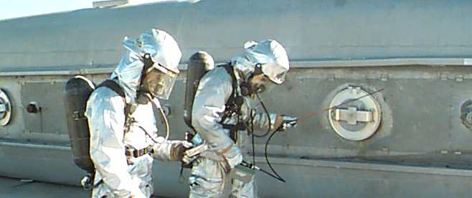

NUCLEAR SERVICES
SIN 899-8 Remediation Services

As part of Eagle’s in-house capabilities, Eagle’s Nuclear Services Divisions maintains a radiological control staff consisting of highly experienced scientists, managers, waste management specialist, transportation specialists, technical writers, health physicists, and safety professionals. Eagle’s Harriman, Tennessee office recently completed work at the East Tennessee Technology Park (ETTP; former K25 facility) and the Y-12 National Security Complex. Projects at the above mentioned facilities included removal/fixing, surveying, packaging, shipping of radioactive materials and radioactive sources, and demolition with work performed in radiation areas, soil contamination areas, airborne contamination areas and other contamination areas. Prior to field activities, Eagle’s staff prepared all documentation required to work in the above mentioned areas and handle radioactive materials including work control packages, waste handling plans, transportation plans, and health and safety plans (including AHAs). Eagle also prepared and executed MARSSIM survey and release plans for radiological facilities. Eagle’s in-house waste management/transportation division prepared 2109 forms, waste profiles and performed field surveillance including manifesting, transportation logs, certification forms, and other packaging and shipping documentation.

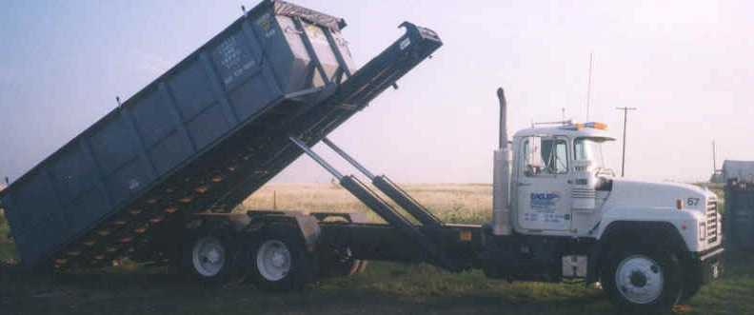

INDUSTRIAL TRANSPORTATION

SIN 899-8 Remediation Services

Eagle’s Industrial Transportation Division is constantly on the go offering a comprehensive range of services and conveniences to a broad range of clients. Eagle’s fleet of dump trucks, vacuum trucks, Super Sucker/Air Mover trucks, roll-off trucks, roll-off containers and numerous other storage vessels are available for use at a moment’s notice for any situation that may arise.
With disposal options ranging from incineration, deep well injection, land filling, neutralization, and micro/macro encapsulation, Eagle has the knowledge and resources to manage any waste.

- Roll Off Containers (Rental and Transportation)
- Vacuum Boxes
- Industrial Waste Management
- Lab Packs
- Solid and Liquid Hazardous/Non-Hazardous Waste Transportation and Disposal
- Roll-Off Boxes, Frac Tanks and Poly Tank Rentals
- Vacuum Truck Service
- Super Suckers (Rail Ready)

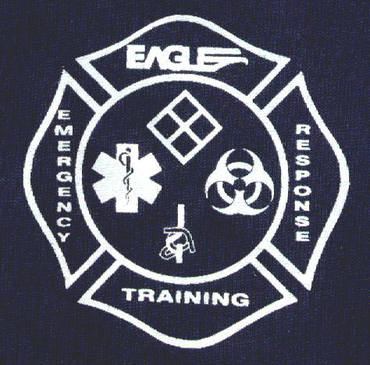

TRAINING
SIN 899-3

Eagle's Training Division is well known for the level of reality involved with the hands-on scenarios. The classroom portion of the training is designed to supplement the real-time exercises in order to give the students a well-rounded level of knowledge and expertise.
The Training Division has provided consulting, technical services and training for public, private and governmental sector clients statewide, nationally and internationally. It also specializes in providing insight into all facets of Emergency Response Operations.

For more information please call the Training Division @ 800-336-0909

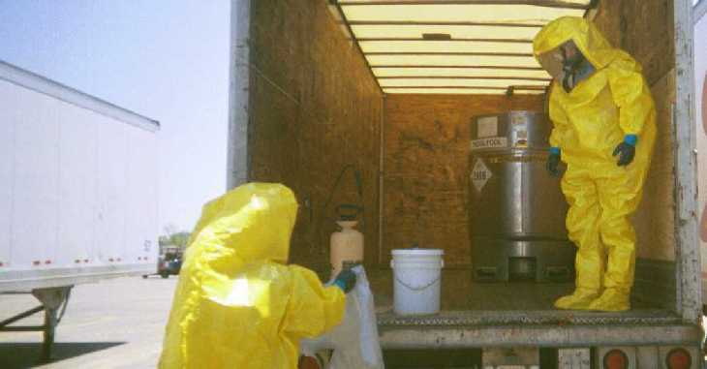

TECHNICAL SERVICES
SIN 899-8

Eagle’s Technical Services Division specializes in areas of environmental response and groundwater investigations and remediation, environmental auditing and compliance for national consulting and engineering firms as well as a wide range of services for industrial and government agencies. These activities are headed by our staff of Registered Professional Geologists and Corrective Action Project Managers (CAPMs), hydro geologists, chemists, biologists, and environmental scientists. Eagle’s technical specialists also specialize in monitoring, reporting, and operating and maintaining groundwater systems throughout Texas.

- The primary services include Phase I, II, III environmental site assessments (ESAs)
- Baseline environmental site assessments (BEAs)
- Hydro geological investigations, including groundwater modeling; water supply evaluations, wetlands delineation, remediation system design and implementation for both contaminated soil and groundwater
- Facility audits for environmental compliance and/or health and safety issues
- Underground storage tank (UST) management
- Feasibility analysis and risk assessments
- Closure documentation
- Geoprobe drilling and mobile laboratory services
- Asbestos and lead sampling management
- Brownfield projects
- Risk-based closures
- Landfill consulting including groundwater investigations
- Environmental Audits
- Remedial Investigation/Feasibility Studies (RIFS)
- Remedial Action Plans (RAPs)
- Remedial Design
- Remedial Action Management
- RCRA Facility Investigation (RFIs)
- Regulatory Compliance and Permitting
- Contingency/Pollution Prevention Audits and Plans
- Oil Pollution Act ‘90 Audits and Plans
- Industrial Hygiene and Safety
- Special Resources (Wetlands, Endangered Species)
- Permitting
- Noise Surveys
- Pond and Lagoon Closures
- UST Removals & AST Installations (Corrective Action Project Managers On Staff)
- Ground Water Remediation
- UST Decommissioning and AST Installations

SAFETY MISSION

Safety is our most important mission. At Eagle Construction and Environmental Services, L.P., our commitment to safety is based on our vision to be the best full-service environmental and construction company by setting the standards for our industry.
Eagle believes accident prevention is a constant shared responsibility. It is through every employee and subcontractor’s active participation that Eagle intends to be in full compliance with all applicable Federal, State, and local standards. Additionally, all Eagle employees, without exception, are held accountable for the support of the health and safety program, for the prevention of accidents, for their own personal safety, and for the safety of their coworkers.
In order to fulfill this mission, we are committed to the following principles by:

- Providing appropriate employee training so that each person is able to acquire the knowledge and skills needed to work in a safe and responsible manner.
- Providing equipment, tools, and materials that are safe and appropriate for the task at hand.
- Providing effective safety and health management at all levels in the company.
- Developing and maintaining reasonable safety rules and standard operating procedures and effectively communicating these rules, practices and procedures to all employees.
- Firm and fair enforcement of the company safety rules and procedures.
- Providing the appropriate medical and industrial hygiene programs and services for employee health conservation.
- Promoting employee safety and health both on and off the job.

CERTIFICATIONS

Eagle staffs a wide array of professionals including environmental scientists, chemists, geologists, hydrologists, biologists, engineers, safety specialists, quality control specialists, project managers, equipment operators and environmental technicians. These professionals are fully trained in emergency response and hazardous materials handling as well as in depth training in each respective area of expertise. Specific training and certifications held by Eagle employees are detailed below.
Eagle maintains multiple license and certifications enabling us to provide a broad spectrum of environmental services throughout the United States. Permits maintained by Eagle provide a company that is capable of performing projects from start to finish including remediation, demolition, emergency response, hazardous and non hazardous waste hauling, UST removals, and special waste handling. A partial listing of the permits held by Eagle are detailed below.

Corporate
- TCEQ Reg. No 41981
- TCEQ UST Contractor No. CRP000209
- TCEQ Sludge Transport No. 21700
- TCEQ LPST CAS No. RCAS00088
- TCEQ Used Oil Filter Reg. No. A85790
- TDH Asbestos Transport No. 40-0109
- TDPS Texas Control Substance Registration
- TXDOT ICC No. 239584
- US DOT Reg. No. 062303 088 014LM
- US DOT 434064
- TRRC Reg. No. 0000038207
- U.S. Coast Guard OSRO Certification
- US EPA No. TXD987983715
- US Trademark Certification Registration
- State of Tennessee Hazardous Waste Transportation Permit TXR000061481

Personnel
- Emergency Response Foremen with a minimum of 5 years experience
- 29 CFR 1910.120 Section E Hazardous Waste Operations 40 Hour
- 29 CFR 1910.120 Section Q (iii) Emergency Response Technicians
- OSHA 29CFR 1910.120 Sec. E8 and Q8 - Hazardous Materials Safety Training
- Tank Car Specialists, Pueblo, CO
- 29 CFR 1910.120 Section (v) On Scene Incident Commanders
- Chlorine Specialists (A, B and C Kits)
- Louisiana Department of Environmental Quality UST License
- R.A.P.I.D 7200 Manufacturer Training
- 29 CFR 1910.120 Section (iv) Hazardous Materials Specialists and special product training
- First Aid/Adult CPR
- Site Safety Officers and Specialists
- Qualified Heavy Equipment Operators
- Qualified and Experienced Truck Drivers with hazardous Materials Endorsement
- Environmental Professionals (professional engineers, biologists, chemists, hydrologists, geologists, environmental engineers, etc.)
- Leaking Petroleum Storage Tank Corrective Action Project Managers
- Reactive Chemicals and Ordinance Trained Personnel
- Texas Certified Fire Fighters with industrial fire fighting experience
- Leaking Petroleum Storage Tank Corrective Action Project Managers
- OPA ’90, RSPA, MMS, Oil Spill Response
- Texas Railroad Commission Liquid Petroleum Gas Installation Certification
- HazCat Identification Course
- OSHA 29CFR 1910.120 Supervisor Training Course
- Chemical Transfer Training
- TCEQ Class A & B Licenses for Underground Storage Tank Removals and Installations
- Arkansas Licensed Contractor
- Louisiana Licensed Contractor
- Spanish/English Translators
- Arizona Licensed Contractor
- New Mexico Licensed Contractor

HUBZone

In December of 2003, Eagle was approved as a certified HUBZone small business concern (HUBZone Application Number 13918 / PRO-Net ID PO116597). This certification provides an added benefit for Federal contractors in providing a proven full service environmental contractor with the personnel, equipment and experience in the performance of hazardous and non-hazardous remediation, sludge and soil stabilization, site closures, radiological remediation and decontamination and demolition services who is also a certified HUBZone certified small business.

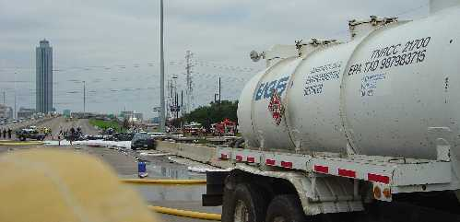

CLIENT SATISFACTION

"When the time came for your team to do their job they were prepared, organized, efficient, and did an exemplary job. Of all the contractors on scene, it was EAGLE'S team that was most professional, prepared and efficient." --Chris W. Gautreau, Terminal Manager, LOGEX

"The level of professionalism of your staff left no doubt that the clean up effort would be done to the satisfaction of all of the parties concerned."--Chris Champagne, Plant Engineer, Borden Chemical, Inc.

"It is really nice to work with a contractor that not only does what is agreed, but is willing to do more when it is necessary in order to get the job done." --Charles P. Gillespie, Jr., P.E., President, Consulting Environmental Engineers, Inc.

"The working conditions were far from desirable, but their collective "can-do" attitude impressed me greatly."
--Robert F. Cammack, Building Operations Manager, Trammell Crow Company

"We are truly fortunate to have a long-standing relationship with Eagle. Based on your superb performance in the past, and during this situation, you can be sure I'll recommend Eagle Construction and Environmental Services to all of my business associates." --Gilbert H. Becker, General Manager, International Paper

"The training staff is professional and the segments of training that we monitored was of excellent quality."--Sgt. Carl Bennett, Louisiana Emergency Response Training Center

"I appreciate your immediate response and professionalism to our matter. Your company did an outstanding job!" --Jacki J. O'Reilly, David's Patio Inc.

“The spirit of cooperation between our staff is something we all can be proud of. Eagle gave us a first rate final product.” --Larry Henderson, Superintendent, National Park Service

“The reaction time from initial call to having people onsite is exceptional.” --Alan K. Angers, Project Manager, American Airlines

“Eagle strives to provide top quality at all times.” --Norman D. Wishnow Contracts Manager City of Houston

“There are a lot of good people working for you and I think you have put together a great team. I know when I call Eagle the job will get done right the first time” --Ken Clark Sr., Engineer, Bell Helicopter Textron

“Eagle’s flexibility, responsiveness, and creativity were of a great assistance to us in managing and responding quickly to these changes.” --J. David Highland, P.E. Parsons Engineering Science

Government Awarded Prices (Net Prices)
LABOR CATEGORY NAME
SIN NUMBER 899-3 |  |  | Hourly
Lead Instructor |  |  | $ 69.82
Assistant Instructor |  |  | $ 47.88
Course Development |  |  | $ 79.80
PowerPoint Design |  |  | $ 79.80
Training Consultant |  |  | $ 79.80
Administrative Assistant |  |  | $ 29.92
SIN NUMBER 899-8
Administrator, Project/Logistics | $42.46
Clerical/Secretarial, Project | $23.94
Disposal Coordinator | $49.87
Draftsman | $33.16
Foreman, Emergency Response | $54.86
Foreman, Remediation/Other Field Services | $42.64
Laborer, Non-Hazardous | $26.93
Manager, Resource Liaison | $44.88
Mechanic | $39.90
Officer, Site Safety | $69.82
Operator, Equipment | $44.88
Supervisor, Emergency Response | $64.83
Supervisor, Industrial Hygiene | $72.06
Supervisor, Remediation/ Other Field Services | $56.85
Supervisor, Senior Project | $69.82
Supervisor, High Hazard/ Reactive/ Explosive/ Cylinder | $159.60
Technician, Emergency Response | $44.88
Technician, Industrial Hygiene / Environmental | $39.90
Technician, High Hazard/Reactive/Explosives/Cylinder | $119.70
Engineer | $79.80
Geologist/ Hydrogeologist, Senior | $79.80
Geologist / Hydrogeologist | $66.83
Industrial Hygienist / Safety Prof | $85.28
Manager, Project / Operations | $75.81
Scientist, Project | $66.83
Scientist, Senior | $75.81
Specialist, High Hazard / Reactive / Explosives / Cylinder | $75.81
Course Title for
SIN NUMBER 899-3 |  | Course Price
Hazard Communication |  |  | $548.63
First Responder Awareness |  |  | $897.75
First Responder Operations |  |  | $1596.00
Hazardous Materials Tech |  |  | $2394.00
HAZWOPER |  |  | $3790.52
HAZWOPER Refresher |  |  | $972.57
Incident Command |  |  | $897.75
Confined Space Entry |  |  | $897.75
Confined Space Entry and Rescue |  |  | $1895.26
First Aid and CPR |  |  | $648.38
Oil Spill Technician |  |  | $4588.52
HM-181 (DOT) |  |  | $1117.20
Lock – Out / Tag – Out |  |  | $548.63
RCRA Awareness |  |  | $917.70
Ford Truck Safety |  |  | $917.70
Lead Awareness |  |  | $573.57
Asbestos Awareness |  |  | $578.55

PROJECTS

Department of the Navy - Region 6 Environmental Multiple Awards Contract
Eagle currently maintains the Environmental Multiple Awards Contract (EMAC) with the United States Department of the Navy (Navy) for U. S. EPA Region 6 (Texas, New Mexico, Arkansas, Oklahoma and Louisiana). The contract generally consists of remedial action services at environmentally contaminated sites predominately located at Navy and Marine Corps installations and other Government agencies. Remediation sites consist of those ranked on the Superfund National Priority List (NPL) as well as non-NPL sites regulated under the Comprehensive Environmental Response, Compensation, Liability Act (CERCLA), Resource Conservation and Recovery Act (RCRA), Underground Storage Tanks (UST) and various other sites that may require remediation.

K-1064 Peninsula and Laboratory Area D&D
Eagle was awarded the K-1064 Peninsula and Laboratory Area D&D contract by Bechtel Jacobs Company (BJC). Eagle is currently performing the services described throughout the following. The scope of work is for the Decontamination and Demolition (D&D) of two groups of facilities at two different sites. These groups of facilities are the K-1064 Peninsula (K-1064 Area) and the Laboratory Area (Lab Area) facilities. The Lab Area facilities consist of 23 facilities, and the K-1064 Area consists of 17 facilities (with ancillary structures).

Task Release 19A; Administration Building Demolition BWXT Y-12
Eagle was awarded Task Release 19A under a five year General Order Agreement (GOA) based on best overall approach and value to the government. Work is located at the Y-12 National Security Complex, a government-owned facility, managed by BWXT Y-12, for the Department of Energy (DOE), in Oak Ridge, Tennessee. The work involving the TR-19A Facilities demolition was performed within the Property Protection Area of the Y-12 Complex.

City of Houston Emergency Response and Hazardous Materials Management Contract
Eagle currently holds a citywide contract for the emergency response to hazardous materials releases for the City of Houston, Texas. Environmental services required under this contract include Emergency Response, non-emergency remediation and the handling, transportation and disposal of hazardous, non-hazardous, toxic and/or reactive materials. Services are required under this contract on a 24 hour per day, seven days per week basis for all city departments.

International Airlines - Nation Wide Emergency Response Contract
Eagle Construction and Environmental Services is currently contracted by several international airlines to provide environmental emergency response services to over 175 airports in North and South America. Clean up activities require Eagle to implement proper means of control, containment, store, labeling, removal, and prevention of any further release of the substance into the environment. Eagle’s services also include response to catastrophic events including those associated with fire, explosion, floods, earthquakes, terroristic threats involving WMDs, aircraft incidents and equipment failures.

TCEQ PST ER Contract
Eagle Currently Maintains an Emergency Response & Supplemental Site Activities in the North and South Regions (which covers the entire State excluding far west Texas) for the Texas Commission on Environmental Quality (TCEQ). Under this contract, Eagle performs emergency response services for Petroleum Storage Tank (PST) releases, including locating the source, and spill containment and removal. In addition, Eagle’s services include conducting explosive vapor assessments, receptor surveys, water well inventories and sampling, installation of receptor trenches, recovery wells, and remediation equipment. Activities also include performing site assessments, monitoring well installation and sampling, quarterly monitoring, and UST removals.

TCEQ Hazardous Materials ER Contract
Eagle currently holds 4 of the 5 regional contracts to provide Emergency Response Services for the TCEQ throughout Texas. Services performed include emergency response activities required to control and respond to incidents involving the release of hazardous, non-hazardous and petroleum products, location and sampling of potentially contaminated water wells, as well as responding to the release of petroleum, hazardous, non hazardous, toxic and environmentally regulated substances.

Refining Company Salvage and Demolition
Eagle has several large-scale petrochemical, smelter and other plant salvage and demolition projects in progress. Eagle maintains a list of buyers throughout the world who purchase used facility components. Concurrent with salvage operations, Eagle commences decommissioning and demolition activities.

Hazardous Materials Remediation
Eagle was contracted to perform the demolition and removal of hazardous materials present at the Industrial Wastewater Treatment Plant (IWTP) and in the main industrial area of an industrial facility in East Texas. Activities performed include the demolition and removal of three concrete sludge drying beds, a 12-foot security fence, a 10,000 gallon elevated sludge holding tank, three concrete sumps and associated piping and valves.

Former Wood Preserving Facility CERCLA Remediation
Eagle was contracted to provide environmental construction and excavation services at a former wood-preserving site located in Madisonville, Louisiana. The project was funded and directed by U.S.E.P.A. Region 6. Eagle’s scope of work included redesign and construction of a DNAPL recovery and wastewater treatment system, construction of temporary and permanent decontamination facilities, road construction, clearing and grubbing, contaminated materials excavation and handling, decontamination, hazardous and non-hazardous waste transportation and disposal, demolition, site security, site safety, and air monitoring.

Solid Waste Landfill Removal - President George Bush Turnpike Extension
Major construction activities associated with the extension of the President George Bush Turnpike in North Texas were planned to traverse a large section of the former Farmer’s Branch Landfill. Eagle was contracted to perform the excavation and removal of more than 100,000 tons of municipal solid waste from the closed Landfill to allow construction to continue through the area.

Former Rail Car Fabrication Plant - Demolition/Remediation
Eagle was contracted to perform demolition activities at a former railcar fabrication facility. The facility was located on a 24 acre site. The main facility structure was approximately 653,000 square feet and consisted of multiple side structures such as warehouses, paint booths, blasting booths and fabrication booths. Adjacent to the fabrication facilities, a two-story concrete administration building with asbestos containing material (ACM) was present.

Conroe Creosoting Co. Superfund Site
The Conroe Creosoting Superfund Site is an abandoned wood treating facility situated on 147 acres of land on the outskirts of Conroe, Texas. Approximately 15 acres of the site was utilized to treat wood with creosote, pentachlorophenol (PCP) and copper-chrome-arsenic (CCA). Eagle was contacted by Environmental Quality Management (EQM) to provide construction and environmental services for the USEPA Region 6 office to mitigate the immediate health hazards associated with the Conroe Creosoting Site.

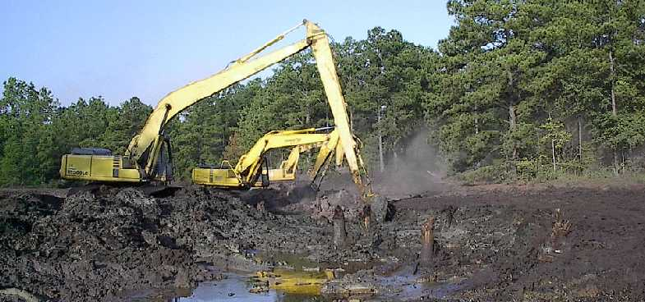

24-HOUR EMERGENCY RESPONSE
1-800-336-0909

OFFICE LOCATIONS

Corporate Office: 9701 East I-20 Contact: MarcWalraven
Eastland, Texas 76448 E-Mail:marcw@ecesi.com
Phone: (254) 629-1718 Cell: (817) 829-7569 Fax: (254) 629-8625

Fort Worth Office: 9204 Highway 287 N.W. Contact: Robb Clay
Fort Worth, Texas 76131 E-mail: robbc@ecesi.com
Phone: (817) 847-1333 Cell: (817) 829-0647
Fax: (817) 306-8086

La Porte Office: 1700 North E Street Contact: Reggie Grimes
La Porte, Texas 77571 E-mail: reggieg@ecesi.com
Phone: (281) 867-9131 Cell:(281) 541-7826
Fax: (281) 867-9150

San Antonio Office: 414 FM1103 Contact: J.T. Ponder
Cibolo, Texas 78108 E-mail: jtponder@ecesi.com
Phone: (210) 566-8366 Cell: (210) 389-1069
Fax: (210) 566-6247

Louisiana Office: 10049 Industriplex Contact: Mark Allen Gonzales, Louisiana 70737 E-mail: marka@ecesi.com
Phone: (225) 677-7877 Cell: (225) 235-1403
Fax: (225) 677-5474

Ohio Office: 3820 Ventura Drive Contact: John Seifert
Findlay, Ohio 45840 E-mail: johns@ecesi.com
Phone: (419) 425-5845 Cell: (419) 348-4127
Fax: (419) 425-5851

Tennessee Office: 1877 S. Roane Street Contact: Brian Turner
Harriman, Tennessee 37748 E-mail: briant@eagletn.com
Phone: (865) 882-7717 Cell: (865) 712-8756
Fax: (865) 882-7719

Elkhart Office: P.O. Box 1020 Contact: Jamie Caffee
Elkhart, TX 75839 E-mail: jamiec@ecesi.com
Office: (903) 764-5621 Cell: (817) 556-8380
Fax: (903) 764-5623
National Railcar Office: P.O. Box 729 Contact: Kevin Tate
Roscoe, TX 79545 E-mail: kevint@ecesi.com
Office: (325) 766-3313 Cell: (325) 766-3044
Fax: (325) 766-3155

