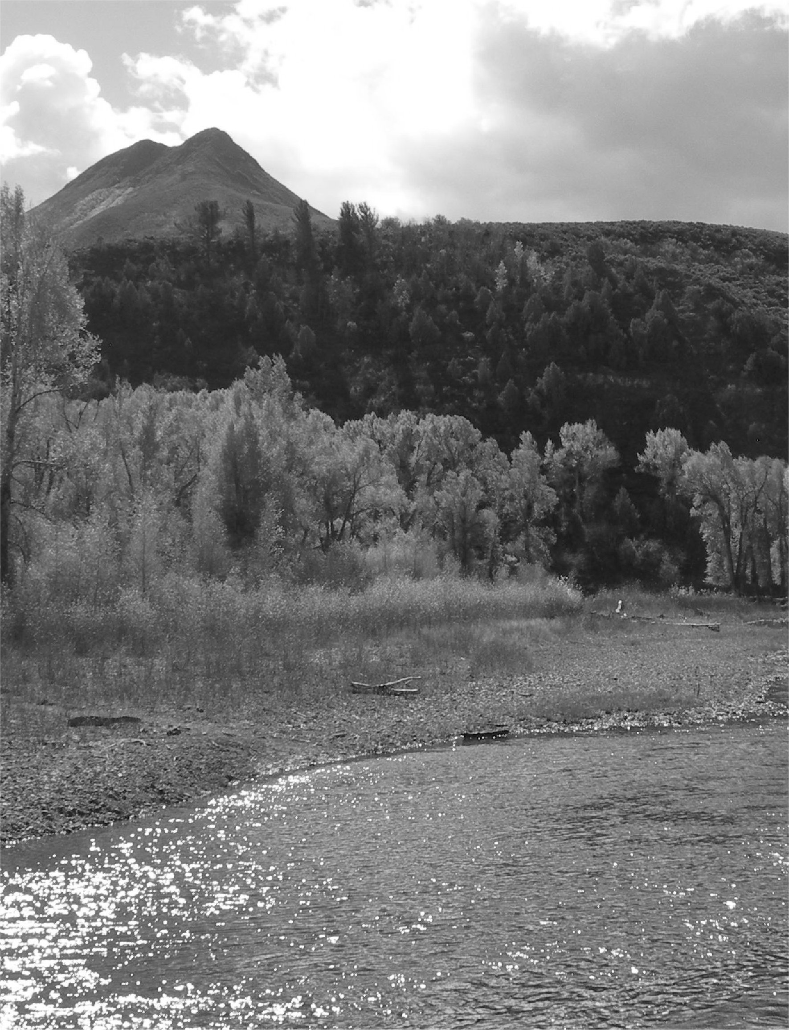


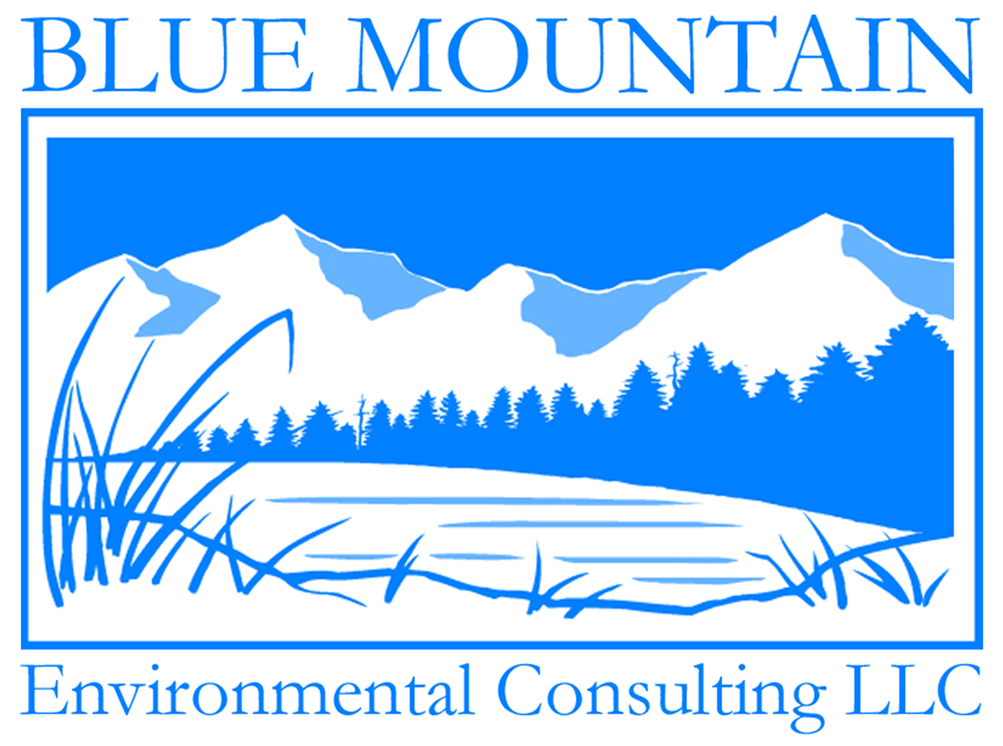

Fort Collins, CO • Sand Lake, NY
(970) 224-0851 • www.bluemountain1.net

Conserving resources,
helping people

GSA Advantage: GS-10F-0066X

About Us
Government Contracting
Ordering environmental services from Blue Mountain’s GSA schedule provides federal agencies with an easy, cost-effective way to operate a sustainable business.

Structure: SBA Small Business
DUNS: 098402790
Cage Code: 5CNN8
Contact: Matt Tobler
Email: matt@bluemountain1.net
GSA Advantage: GS-10F-0066X

NAICS CODES
541620 Environmental Consulting Services. 541690 Other Scientific & Technical Consulting Services. 541712 Research& Development in the Physical, Engineering & Life Sciences. 712190 Nature Parks & Similar Institutions. 813312 Environment, Conservation & Wildlife Organizations. 115116 Farm Management Services. 713920 Skiing
Facilities. 115 Support for Agriculture and Forestry.

Since 2001, Blue Mountain Environmental Consulting has provided ecological services, conservation planning and environmental compliance services to landowners and managers throughout the Rocky Mountain west. Our commitment to sustainable environmental management and conservation has established Blue Mountain Environmental Consulting as a leading natural resource management organization for landowners, non-profit organizations and government agencies. We provide ecologically based resource management strategies to achieve project outcomes in an efficient, sustainable and responsible manner. We offer:

- Conservation & Open Space Planning
- Ecological & Environmental Services
- Wetland & Riparian Area Management
- Forestry & Wildfire Mitigation
- Rangelands & Noxious Weed Management
- Geographic Information Systems (GIS)

Experience: Our accomplished teams of resource professionals have experience in botany, ecology, forestry, wildfire mitigation, ecosystem restoration, wildlife management, rangelands, erosion control, wetlands, communications, policy and geographic information systems. Our diverse capabilities, decades of experience and integrated approach position Blue Mountain Environmental Consulting to be able to provide insightful and practical solutions for a wide array of projects both large and small. We have experience with federal and state agencies, local municipalities, non-governmental organizations, foundations, landowners and other decision makers. We have collaborated on National Environmental Policy Act projects addressing power generation and transmission, water storage and conveyance and communications infrastructure. We have also conducted watershed assessments, ecological inventories, management planning and far more.

Service: Much like our philosophy on environmental planning, Blue Mountain Environmental Consulting is built upon sustainability. As a small business, we are more accessible to our clients and more responsive to their needs. Our project teams are tailored to fit the unique needs of each individual project while our efficient business structure allows us to allocate a greater portion of project resources directly upon deliverables.
Conservation & Open Space Planning


At Blue Mountain Environmental Consulting, we understand the challenges that landowners and managers face and the tools that can be used to meet land use goals including conservation easements, grazing plans, NRCS Technical Services, Rural Land Use Plans and other programs. As a rancher, agency manager, residential landowner, conservation partner or owner of an exclusive property, we can help you navigate the thicket of incentives and regulatory programs to balance the needs of your working landscape. With decades of experience on rural lands, our roots are in agriculture.

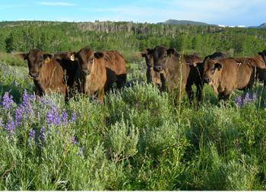
Whether developing a conservation easement baseline report, documenting conservation values, managing noxious weeds, developing a custom grazing plan to fit your operation, a forest management plan or integrating an easement with other conservation programs, we have the tools and expertise necessary to make your project a success. We work extensively with the NRCS, numerous land trusts, county governments and the Department of Natural Resources to meet a variety of resource management needs. Contact us to discuss how the following services can help you achieve your goals.

- Conservation Easement Baseline Reports
- NRCS Technical Services
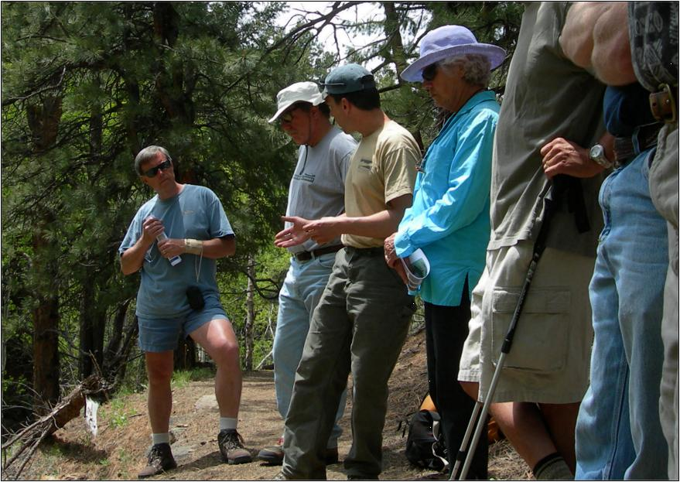
- Grazing Plans and Rangeland Management
- Phase 1 Environmental Assessments
- Rural Land Use Plans
- Open Space Management Plans
- Resource Management Plans
- Strategic Planning
Conservation success begins with strong relationships. We will work closely with you to be sure that we understand your needs and move your project through to completion in a timely manner.

Ecological & Environmental Services


Blue Mountain Environmental Consulting offers a wide variety of ecological and environmental services to meet the needs of land holding agencies and private sector project proponents. Functioning independently, or in collaboration with other environmental organizations, we have participated in NEPA (National Environmental Policy Act) projects across western states addressing forest management, oil and gas infrastructure development, communication facility construction, water development and conveyance. Our team of ecological experts has conducted wetland delineations, threatened and endangered species surveys, rare plant surveys, and ecological assessments. We provide the following services:

- Threatened and Endangered Species Surveys
- Ecological Field Studies
- Baseline Biological Surveys
- Phase 1 Environmental Assessments
- Due Diligence
- NEPA Support
- Wildlife Management
- Stormwater Management Plans
- Regulatory Compliance
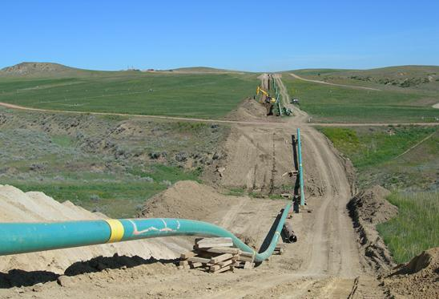

Central to the NEPA process is the description of the affected environment and quantification of proposed project impacts. In the gas pipeline project pictured here a survey for sensitive species was conducted and the affected environment was described for an environmental impact statement.

Wetland & Riparian Area Management

To meet the complex needs of wetlands and riparian areas, Blue Mountain Environmental Consulting employs multidisciplinary teams to conduct wetland delineations, 404 Permitting, Riparian Proper Functioning Condition Assessments, Rosgen Channel Evaluations, fisheries habitat evaluations and stream flow duration assessments.

Working hand-in-hand with federal agencies, non-profit organizations and residential landowners, we have experience with a variety lentic and lotic wetlands throughout the Rocky Mountain west including high-elevation fens, large rivers on the eastern plains, grazed riparian systems in the intermountain west and flashy intermittent arroyos of the desert southwest. We also provide erosion and sedimentation control services, ecological restoration, and a vast assortment of other services to suit the needs of your project. We can assist you in any of the following areas:

- Wetland Delineation and 404 Permitting
- Riparian Functional Assessments
- Fisheries Habitat Assessments
- Rosgen Channel Evaluations
- Sub-meter Boundary Mapping
- Sedimentation and Erosion Control
- Stream Flow Duration Assessments
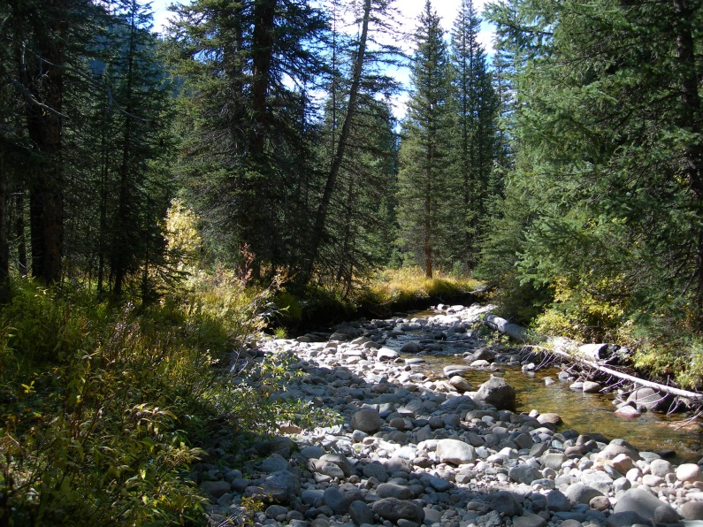
- Restoration

Rangeland & Noxious Weed Management

At Blue Mountain Environmental Consulting, we understand the challenges that landowners and managers face; we can provide assistance with NRCS Conservation Programs and provide a variety of other services to meet the needs of your working landscape. With decades of experience on rural lands, our roots are in agriculture.

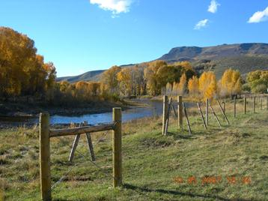
Serving the needs of federal and state agencies, Blue Mountain Environmental Consulting offers qualitative and quantitative rangeland services that can be scaled to fit budgetary constraints and program needs. Our approach to rangeland management includes rigorous techniques, such as Modified-Whittaker sampling protocol and North American Invasive Plant Mapping Standards, used in conjunction with our GIS capabilities to efficiently characterize ecological resources and summarize project findings in meaningful ways. Our approach creates efficiencies in your management plans and useful information for managers.

Our services include:


- Grazing Management Plans
- NRCS Technical Services
- Noxious Weed Inventories and Management
- Vegetation Inventories
- Rangeland Utilization Studies
- Monitoring Programs

The Forest Health Monitoring Plot (right) can be used to capture a variety of ecological information.

Forestry & Wildfire Mitigation

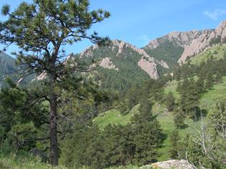

At Blue Mountain Environmental Consulting, our extensive experience with forest management and wildfire mitigation within the wildland urban interface results from working directly with landowners and managers. In former forestry projects, we have worked with residential landowners to develop State approved Forest Agricultural Plans that qualify landowners for a tax credit, developed stewardship plans for reservoir watersheds to mitigate the threat of wildfire, and created comprehensive planning documents for gated communities to both restore forest health and mitigate wildfire while developing a consensus among residents to resolve conflict.

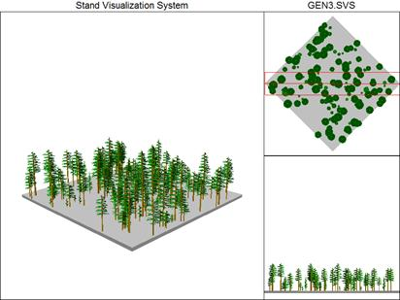
Forests in many parts of the Rocky Mountain west have undergone significant changes since the late 1800s. Forest density has increased, leaving many areas prone to catastrophic wildfire as well as insect and disease outbreaks such as the Mountain Pine Beetle epidemic. Increasingly, people have become dependent upon maintaining existing conditions within dynamic forest systems that were historically regulated by natural forces. Development within the wildland urban interface leaves residential property vulnerable to catastrophic wildfire, which can also impair municipal water supply systems and diminish property values.

We are happy to leverage our extensive forestry experience in any of the following areas:

- Forest Agricultural Plans
- Ecosystem Management Plans
- Forest Stewardship Plans
- Defensible Space Marking and Consultation
Forest composition and structure are inventoried with custom sampling protocols and depicted graphically to communicate conditions.

- Forest Insect and Disease Consultation
- Site Plan Review
- Wildfire Mitigation
Geographic Information Systems (GIS)


An essential tool for resource managers, ecologists and land planning professionals alike, Geographic Information Systems (GIS) have revolutionized the ecological service industry. Blue Mountain Environmental Consulting offers a full suite of spatial information services for your needs, including:

- GIS Maps and Database Development
- Spatial Analysis and Modeling
- Sub-meter Geographic Positioning System Mapping
- Spatially Explicit Documentation
- GIS Training and Support
- Strategic Planning

Whether you need a map of your property, sub-meter field mapping of wetland boundaries or ecological modeling services, we have the tools and experience to help. With a wide array of spatial information at our fingertips, we can compile existing information to document conservation values, develop predictive models and geo-reference field data in addition to a wide array of informational services.

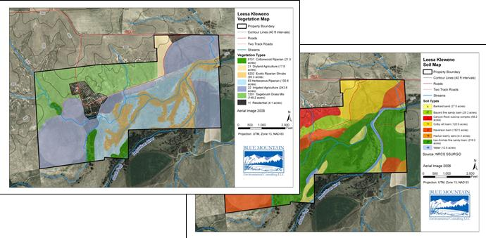
The Blue Mountain philosophy for providing effective resource management is clear and concise communication. To this end, we strive to make insightful, efficient and effective use of GIS technology to support project goals in ways that are meaningful to you.

GSA Contracting

Ordering GSA Environmental Schedule Services (899-1)
GSAAdvantage.gov
On-line access to contract ordering information, terms and conditions, up-to-date pricing and the option to create an electronic delivery order are available through GSA Advantage!, a menu driven database system. For more information on ordering from Federal Supply schedules click on the FSS Schedules button at fss.gsa.gov.

Structure: SBA Small Business
DUNS: 098402790
Cage Code: 5CNN8
Contact: Matt Tobler
Email: matt@bluemountain1.net
GSA Advantage: GS-10F-0066X

NAICS CODES
- 541620 Environmental Consulting Services.
- 541690 Other Scientific & Technical Consulting Services.
- 541712 Research & Development in the Physical, Engineering & Life Sciences.
- 712190 Nature Parks & Similar Institutions.
- 813312 Environment, Conservation & Wildlife Organizations.
- 115116 Farm Management Services.
- 713920 Skiing Facilities.
- 115 Support for Agriculture and Forestry.

The steps for ordering environmental services from Blue Mountain’s GSA Environmental Services Contract are outlined below. Additional information regarding the ordering process can be obtained by contacting Blue Mountain’s contracting officer, Matt Tobler at (970) 224-0851. The GSA Federal Supply website (fss.gsa.gov) also provides information on ordering guidelines, procedures and customer support services.

- Statement of Work
Develop a Statement of Work for any of the services offered by Blue Mountain Environmental Consulting GSA Environmental Schedule Contract (SIN 899-1, 899-1 RC).

- Cost Estimate
Develop a Cost Estimate based on your agencies standards.

- Research Contractor Information
Research on-line to obtain contract ordering information, terms and conditions and pricing at GSA Advantage! (GSAAdvantage.gov). Information on services provided by Blue Mountain Environmental Consulting can be found at our website (bluemountain1.net).

- Request Quote
Issue a Request for Quote (RFQ) using the GSA e-Buy system (ebuy.gsa.gov) to firms holding GSA Environmental Service Contracts that you determined to be qualified for the work.

- Best Value
Determine the Best Value provided by contractors’ responses to your RFQ for the scope of work outlined in the statement of work. Consider cost savings, experience and service when determining the best value contractor.

- Task Order
Issue a Task Order to the firm offering the best value, services and technical expertise and award the work under their current GSA contract. The GSA Environmental Services Contract for Blue Mountain Environment Consulting is GS-10F-0066X.
Customer Information

- (a) Awarded Special Items Numbers (SINs)
CONTRACT NUMBER
GS-10F-0066X

CONTRACT DURATION
30 Dec. 2010—29 Dec. 2015

SPECIAL ITEMS NUMBER (SINS)
899-1, 899-1 (RC)

CONTRACTOR POINTS OF CONTACT
Matt Tobler, MS
Blue Mountain Environmental
Consulting
937 Mallard drive
Fort Collins, CO 80521
T: 970.224.0851
F: 970.224.0850
matt@bluemountain1.net

WEBSITE
www.bluemountain1.net

BUSINESS SIZE
Small Business

DUNS NUMBER
098402790
SIN 899-1; SIN 899-1 (RC) Environmental Consulting Services
(b) Not applicable – See table with approved labor rates
(c) Not applicable – See table with approved labor rates
- Maximum Order: $1,000,000
- Minimum Order: $100
- Geographic Coverage: CO, UT, WY, MT, ID, OR, SD, NM, NV
- Point(s) of production (city, county, and State or foreign country): Fort Collins, Larimer County, CO
- Discount from list prices or statement of net price: All prices herein are net
- Quantity discounts: None offered
- Prompt payment terms: Net 30 days
- (a) Government Commercial Credit Cards: Yes
(b) Government Commercial Credit Cards: Will accept over $3,000
- Foreign items: None
- (a) Time of delivery: Specified on task order
(b) Expedited delivery: Contact the Contractor
(c) Overnight and 2-day delivery: Contact the Contractor
- F.O.B. point(s): Destination
- (a) Ordering address: Blue Mountain Environmental Consulting, LLC, 937 Mallard Drive, Fort Collins, CO 80521, T (970) 224-0851 F (970) 224-0850
(b) Ordering procedures: Not applicable
- Payment address: Blue Mountain Environmental Consulting, LLC, 937 Mallard Drive, Fort Collins Colorado, 80521, T 970.224.0851 F 970.224.0850
- Warranty provision: Contractor’s standard commercial warranty
- Export packing charges: Not applicable
- Terms and conditions of Government purchase card acceptance (any thresholds above the micro-purchase level): Contact the Contractor
- Terms and conditions of rental, maintenance, and repair: Not applicable
- Terms and conditions of installations: Not applicable
- Terms and conditions of repair parts indicating date of parts price lists and any discounts from list prices: Not applicable
(a) Terms and conditions for any other services: Not applicable
- List of service and distribution points: Not applicable
- List of participating dealers: Not applicable
- Preventative maintenance: Not applicable
- (a) Special attributes: Not applicable
- Data Universal Numbering System (DUNS) number: 09-8402790
- Notification regarding registration in Central Contractor Registration (CCR) database: Blue Mountain Environmental Consulting is registered in the Central Contractor Registration (CCR) database.
GSA Awarded Pricing, Labor Categories and Requirements

PRICING FRAMEWORK (HOURLY)
Labor Category | Year 1/Base  Dec 2010 –  Dec 2011 | Year 2  Dec 2011 –  Dec 2012 | Year 3  Dec 2012 –  Dec 2013 | Year 4  Dec 2013 –  Dec 2014 | Year 5  Dec 2014 –  Dec 2015
Principal  Project Manager  Scientist IV  Scientist III  Scientist II  Scientist I  Technician  GIS Specialist II  GIS Specialist I  Word Processor**  Administration II**  Administration I** | $114.54  $94.62  $79.69  $64.77  $49.83  $39.80  $21.92  $74.74  $39.80  $17.63  $34.89  $19.94 | $118.09  $97.55  $82.16  $66.78  $51.37  $41.03  $22.60  $77.06  $41.03  $18.18  $35.97  $20.56 | $121.75  $100.58  $84.71  $68.85  $52.97  $42.31  $23.30  $79.45  $42.31  $18.74  $37.09  $21.20 | $125.53  $103.70  $87.33  $70.98  $54.61  $43.62  $24.02  $81.91  $43.62  $19.32  $38.24  $21.85 | $129.42  $106.91  $90.04  $73.18  $56.30  $44.97  $24.77  $84.45  $44.97  $19.92  $39.42  $22.53
** Indicates SCA eligible categories. See the SCA Matrix following the price list for additional information regarding these labor categories.

The Service Contract Act (SCA) is applicable to this contract and it includes SCA applicable labor categories. The prices for the indicated (**) SCA labor categories are based on the U.S. Department of Labor Wage Determination Number(s) identified in the SCA matrix. The prices offered are based on the preponderance of where work is performed and should the contractor perform in an area with lower SCA rates, resulting in lower wages being paid, the task order prices will be discounted accordingly.

SCA Matrix
SCA Eligible Labor Category | SCA Equivalent Code Title | WD Number
Administrative Assistant I  Administrative Assistant II  Word Processor | 01020 - Administrative Assistant  0102—Administrative Assistant  01613-Word Processor III | 05-3009  05-3009  05-3009

Price adjustments will be made in accordance with Method 1: Price Adjustment for the base contract period and all options exercised shall be in accordance with clause 52.222-43, Fair Labor Standards ACT AND Service Contract Act Price Adjustment (Multiple Year and Option Contracts). When a modification is issued to all contract holders incorporating a revised index of wage determinations, contractors shall notify the Contracting Officer of any increase/decrease claimed under clause 52.222-43 within 30 calendar days after receipt of the modification.

It is our policy to substitute experience for education if an employee does not meet the base educational requirements of a position. If an individual has not yet received their master’s degree and that is a minimum requirement for their position, they can still qualify for the position with five additional years of experience over the minimum requirement.
GSA Awarded Labor Categories & Requirements

Labor Category | Education | Experience | Description
Principal | BS or MS with eight years of experience | 12 years | Accountable for project development, oversight of ongoing and future project ventures, and client interface. Guides Project Manager by providing input on project oversight and management, quality assurance and quality control, allocation of project resources, technical expertise and functional knowledge of project specific tasks. Accreditation by a relevant professional organization.
Project Manager | BS or MS with five years of experience | 7 years | Provides project oversight and management, quality assurance and quality control, allocation of project resources, technical expertise, and functional knowledge of project specific tasks. Leads in the development of project deliverables including directly relevant services and report preparation. Acts as direct contact between Principal, project team, and appropriate governmental personnel. Accreditation by a relevant professional organization.
Scientist IV | BS or MS with three years of experience | 5 years | Functions as senior scientist by coordinating technical and scientific project responsibilities, managing scientist and demonstrating experience in maintaining relevant professional standards and integration of scientific disciplines relevant to the project. Works independently and assists Project Manager in the development of project deliverables including directly relevant services, report preparation, and quality assurance and quality control procedures. Accreditation by a relevant professional organization.
Scientist III | BS or MS with one year of experience | 3 years | Implements technical and scientific project responsibilities with demonstrated experience in maintaining relevant professional standards and integration of scientific disciplines relevant to the project. Works independently and assists Scientist IV in directly relevant services, report preparation, and quality assurance and quality control procedures. Attends post degree professional training via conferences and workshops to expand technical capabilities in pursuit of professional accreditation.
Scientist II | BS or MS with 0 years of experience | 2 years | Assists senior scientists with data collection, analysis and report development. Performs research and solves analytical problems. Takes responsibility for quality assurance and quality control under general supervision. Attends post degree professional training via conferences and workshops to expand technical capabilities in pursuit of professional accreditation.
Scientist I | BS or AS with two additional years of experience | 1 year | Assists team with project responsibilities including fieldwork, data entry and analysis, and completion of project deliverables under direct supervision. Shares responsibilities with GIS Specialist I.
GIS Specialist II | BS or MS with three years of experience | 5 years | Takes lead responsibility for the facilitation of dat collection, GIS data analysis, database development and programming, and GIS deliverables. Responsible for quality assurance and quality control. Manages entry level GIS specialists and technicians. Maintains proficiency with relevant software and understands supporting devices and computing systems.
GIS Specialist I | BS or AS with two additional years of experience | 1 years | Primarily responsible for GPS field data collection, constructing data dictionaries and managing spatially explicit field data including GPS files, data forms and photographs. Shares responsibilities with Scientist I. Works under general supervision of GIS Specialist II.
Technician | AS or enrollment in college or a high school diploma with two additional years of experience | 0 years | Assists in routine fieldwork, data collection and entry under moderate supervision.
Word Processor | BS or AS with two years experience | 1 year | Assists in report generation, technical editing, and quality assurance and quality control measures.
Administrative Assistant II | BA/BS | 2 years | Responsible for secretarial duties, administrative support to executive staff with office management responsibilities. Conducts quarterly reporting to IRS and IFF, maintains QuickBooks, and business accounting. Corresponds with insurance companies and clients on administrative issues. Assumes responsibility for marketing and outreach development and manages Administrative Assistant I.
Administrative Assistant I | AA/As or high school diploma with two years of experience | 0 year | Responsible for secretarial duties, administrative support to executive staff with office management responsibilities, and assistance with the development of project material under moderate supervision.

People
Matt Tobler, M.S., Natural Resource Specialist / Director
Mr. Tobler is a natural resource manager with over 22 years of experience; he currently serves as principal instigator and project leader on numerous ecosystem management projects that integrated forest restoration, wildfire mitigation, rangeland and noxious weed management, wildlife management and riparian management initiatives. Mr. Tobler has conducted numerous field investigations and developed management programs that are based on existing ecological conditions, historical conditions and landowner objectives for clients from the public and private sectors throughout Colorado. He also has ecological project experience in WY, UT, NE, KS, SD, MT, NY, NV, NM.

Mr. Tobler has participated in numerous NEPA projects across western states addressing oil and gas infrastructure development, communication facility construction, FERC licensing, water development and conveyance. In this capacity, he has conducted wetland determinations and delineations, threatened and endangered species surveys, ecological assessments and prepared documentation per NEPA and Section 404 requirements. Matt also has experience conducting ecological investigations both regionally and internationally. As a research associate with the USDA Forest and Range Experiment Station, he designed and implemented original research studies to investigate causes of landscape diversity and vegetative responses to disturbance within ponderosa pine forests of the Colorado Front Range. As a research associate at the Woods Hole Research Center, he assisted in the implementation of a pioneering study that assessed the fire susceptibility of primary tropical rainforest in the northeastern Amazon of Brazil. Matt worked as ranger for the National Park Service, administered conservation programs for the Natural Resource Conservation Service in New York, and implemented wildfire mitigation and forest stewardship programs for the Colorado State Forest Service. His earliest experiences with resource management come from growing up on a dairy farm in upstate New York where he was a farm hand. Matt holds a M.S. in Rangeland Ecosystem Science from Colorado State University and a B.S. in Resource Management and Forestry from SUNY College of Environmental Science and Forestry. He is a Society of American Foresters Certified Forester, an Ecological Society of America Certified Ecologist, U.S.D.A. Natural Resource Conservation Service Technical Service Provider, Colorado Department of Transportation Erosion Control Supervisor and has completed the U.S. Corps of Engineers Wetland Delineation Training.

Geoff Butler, M.S., Wildfire Specialist
Mr. Butler is a highly qualified wildfire mitigation specialist who has extensive experience with wildfire fuels management, hazard assessments, and pre-suppression planning techniques. Geoff has fought fires and been involved with wildland fire management and suppression across the western United States since 1995. During this time he has worked as a firefighter for the U.S. Forest Service, the National Park Service, and the Poudre Fire Authority in Fort Collins, Colorado. In addition to suppression operations, Geoff has been involved in the planning and implementation of prescribed fires, fuels management projects, and pre-suppression and community wildfire projects for private, local government, state, and federal entities. After receiving his M.S. in Forest Sciences from Colorado State University, he served as an interim lecturer in wildland fire management at Colorado State University from 2003 to 2005. Geoff holds a M.S. in Forest Sciences from Colorado State University and a B.A. in Political Science from the University of Colorado.

Joe Farkas, B.S., Operations / Natural Resource and Environmental Economics
Mr. Farkas is a business professional with experience in general business development, public relations support, marketing activities, report generation, and administrative oversight. At Blue Mountain, Joe has assisted with proposal development, marketing outreach, implementation of accounting measures, and other clerical work. He holds a B.S. in Business Administration from Colorado State University and is currently pursing a M.S. in Natural Resources and Environmental Economics from the same institution.

Clint Hinebaugh, B.S., Wildlife Biology / Sportsman
Raised in southern California, an area full of biologic diversity and urban sprawl, Mr. Hinebaugh developed a passion for conservation and hunting at an early age. His passion for the outdoors brought him to Colorado’s Front Range where he obtained a Bachelors of Science degree in Wildlife Biology from Colorado State University. His most recent term of employment involved working with the Colorado Division of Wildlife as an Avian Research Technician. This position enabled him to assist Biologists in an ongoing research project aimed at evaluating the effect of hunting restrictions on a cross section of State Wildlife Areas within the South Platte River Valley including J.K. Tool, Brush, Atwood, Overland Trail, Bravo, Red Line State Wildlife Areas. He has a particular interest in the management and protection of riparian areas and the flora and fauna that encompasses them.

Clint is a certified Aquatic Invasive Species Watercraft Inspector and Decontaminator by the Colorado Department of Natural Resources. An active member of nonprofit organizations including Ducks Unlimited, Pheasants Forever and Quail Unlimited; he is also a member of Safari Club International.

Amy Randell, B.S., Botanist / Technical Communications
Amy Randell is a natural resource specialist with 14 years of experience; she currently serves as a botanist and technical communicator for Blue Mountain Environmental Consulting. Ms. Randell has participated in diverse natural resource management and research projects throughout Colorado, New Mexico and Washington, utilizing various vegetation sampling techniques for biomass, cover, density, and frequency. Focal areas include plant identification, vegetation assessment, rangeland and noxious weed management, threatened and endangered species surveys, riparian management, ecosystem management and conservation planning.

In addition to conducting botanical surveys and developing rangeland management prescriptions for Blue Mountain, she has worked as a research assistant for the Restoration Ecology Laboratory at Colorado State University. In this capacity Amy implemented various research projects including mine reclamation, metal toxicity thresholds of native plant species, and integrated control of weed species on military lands. As a Research Associate with the Natural Resource Ecology Laboratory at Colorado State University, Ms. Randell collected vegetation, soil, and photographic data in support of a landscape-scale assessment of the Grand Staircase Escalante National Monument, Utah, and a fire impact assessment for the Hayman burn west of Denver, Colorado. She identified more than 300 grass, herb and shrub specimens using taxonomic keys; prepared, mounted, labeled and organized herbarium specimens for the Grand Staircase - Escalante National Monument; conducted various soil laboratory analyses and collected vegetation data utilizing the Forest Health Monitoring Plot and Modified Whitaker Plot.

In 2001, Amy completed an independent research project at the Institute of Ecology and Botany, Hungarian Academy of Sciences, on invasive weed management strategies and the utility of a flora database structure. Amy has a B.S. in Rangeland Ecology and Restoration from Colorado State University and has partially completed an M.S. in Technical Communication. Amy is a member of the Colorado Native Plant Society.

Kristie Raymond, Ph.D Candidate, Geographer / Geographic Information Systems
Kristie received her Master of Art in Geography from the University of Nebraska – Omaha with an emphasis on water quality and GIS and a Bachelor of Science in Geography from Northwest Missouri State University. Since then, her career has been focused on GIS, environmental law, and water quality. She has taught GIS, Computer Mapping, and World Regional Geography courses to undergraduate and graduate students at various colleges. She has also utilized her GIS skills and environmental knowledge while working for the City of Omaha, State of Iowa, and the Environmental Protection Agency. Kristie is proficient in ArcGIS, ArcView, ArcINFO, and ArcIMS. Kristie has relational database management expertise and has programming skills in C++, Visual Basic, and HTML.

Craig Severn, M.S., Ecologist
Mr. Severn is an ecologist with 29 years of experience in landscape analysis in Colorado and the western United States. Mr. Severn has a broad understanding of the ecology of riparian, wetland, and upland communities as well as a working knowledge of state and federal laws including NEPA, the Clean Water Act and others. His experience includes plant, vertebrate, and invertebrate communities that western landscapes support. He has performed wetland delineations and designed, managed construction of, and monitored numerous wetland creation/restoration projects as well as conducted studies related to restoration and grazing in upland areas. Mr. Severn has also conducted surveys for state and federal sensitive plant and animal species for numerous environmental impact statements and environmental assessments. Craig holds a Masters Degree in Mineral Resources Ecology from the Colorado School of Mines and a Bachelors degree in Range Ecology from Colorado State University.

Michael Tuffly, M.S., Geographic Information Systems / Forester
Mr. Tuffly has extensive experience with GIS, eco-regional assessments, wildfire assessments, and invasive plants, animals, and pathogens. He has performed an eco-regional assessment of the Utah High Plateaus, and completed a wildland fire assessment for the headwaters of the Arkansas River and Saint Vrain watershed. Michael holds a M.S. in Natural Resource Management and a B.S. in Forestry, both degrees were acquired from Humboldt State University. He is currently performing work on his Ph.D. in Forest Science at Colorado State University.

Representative Clients

We work with diverse clientele including federal, state and local government entities, corporations, consultants, foundations, non-profit organizations and residential landowners. In a recent survey of client satisfaction, conducted by an independent company, our team was rated 95 out of 100 by our current and former clients on criteria ranging from customer service to technical proficiency. Some representative clients include:
"Our Conservation Easement Baseline Reports are as good as any report I’ve ever seen. I have forwarded copies on to the Area and District Managers and to the property owners. All are impressed with the clarity and completeness of the work.”

-- Jay Cooper, Colorado Division of Wildlife

"I think that our Open Space Plan is the best investment Genesee has made since its development."

-- Ryan Babcock, Genesee Foundation

"I've never seen a more comprehensive or understandable approach to land management."

-- Jim Reidhead, Larimer County Rural Land Use Center

"The baseline report prepared for Saddle Pocket Ranch is a cut above those prepared by ERO Inc. as well as smaller companies that specialize in conservation easements.”

-- Mark Weston, Huntsperger & Weston Ltd.

Colorado Anchor Point Group, LLC
Aspen Valley Land Trust
Beaver Creek Resorts
Bonai Shalom
Boulder Co. Parks and Open Space
City of Ft. Collins
City of Longmont
Castle Pines Homeowners Association
Colorado Cattlemen’s Ag. Land Trust
Colorado Division of Wildlife
Colorado Erosion Control, LLC
Colorado Open Lands
Colorado State Parks
Ducks Unlimited
Ecosphere Environmental Services, Inc.
EDAW, Inc.
ENSR, Inc.
U.S. Forest Service
Genesee Foundation
Legacy Land Trust
National Center for Atmospheric Research
Natural Resource Services, Inc.
Park Studies, Inc.
Saddle Pocket Ranch
Sunrise Ranch
Town of Vail
Uniscope, Inc.

Utah Natural Resource Conservation Service

Virginia Mangi Environmental Services, Inc.

Wyoming Ladder Livestock
The Nature Conservancy

Representative Projects

Project Services
- Proper Functioning Condition Assessment
- Aquatic Habitat Inventory & Monitoring Level III Survey
- GIS Database Development

Client
Pat Coffin & Carol Evans
Elko District, BLM
3900 East Idaho Street
Elko, NV 89801
775-753-0349

Timeframe
August 2011 – December 2011

Contract Value
$46,500

Stream Survey and Functional Condition Assessment

Elko County, NV

Blue Mountain was contracted by the Bureau of Land Management, Elko District, to monitor riparian conditions and fisheries habitat within various grazing allotments.

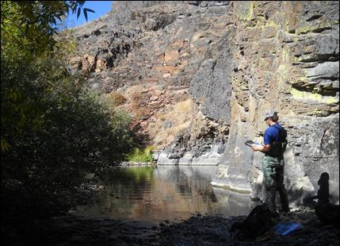
Sixty-three miles of waterways in nine different drainages to monitor the effect of livestock grazing on riparian condition and fisheries habitat. The Proper Functioning Condition assessment (BLM TR1537) was utilized as a qualitative process to evaluate hydrology, vegetation and erosion and deposition processes within each waterway while the Aquatic Habitat Inventory and Monitoring Level III Survey Procedures (Elko Revised Handbook 6720-1) provided detailed information about fisheries habitat and grazing impacts. Waterways occurred within five different grazing allotments, which had undergone different ecological processes such as fire and historical overgrazing. Survey work required accessing extremely remote areas within and adjacent to the Jarbridge Wilderness and assessing conditions on perennial, intermittent and ephemeral drainages. Repeat photographs, survey notes and GPS data were collected to contribute to future monitoring efforts.

Evaluating fisheries habitat and riparian condition on the Lower Bruneau River.

Eleven Mile and Spinney State Park Noxious Weed Management Plan
Project Services
- Noxious Weed Inventory
- GIS Database Development
- Noxious Weed Management Plan

Client
Rob Billerbeck
Colorado State Parks
1313 Sherman Street
Denver, CO 80203
303-866-3203

Timeframe
May 2011 – July 2011

Contract Value
$11,975

Park County, CO

Blue Mountain was contracted to update the noxious weed inventory and create a new management plan for two state parks, which comprised 7,545 acres of rangelands, forests, wetlands and recreational facilities.

Eleven Mile State Park and Spinney Mountain State Park are located in South Park – an expansive high-altitude grassland region of central Colorado bordered to the east and west by the Pike National Forest. Managed by Colorado State Parks under a lease from the Denver Water Board, these parks provide visitors with opportunities for boating, camping, windsurfing, picnicking, birding, waterfowl hunting and nationally renowned fishing.

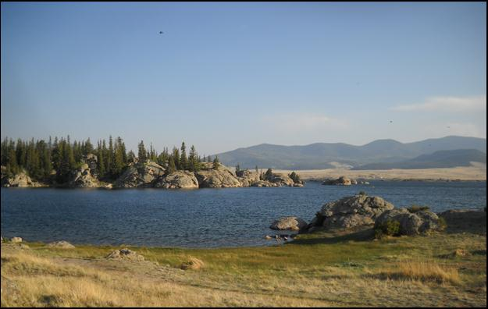
Blue Mountain was contracted to update the noxious weed inventory and create a new management plan for both parks, which comprise 7,545 acres of rangelands, forests, wetlands and recreational facilities. We conducted field inventories and interviews and utilized former assessments to create a new weed map and to track suppression efforts. In compliance with State Park conventions, recommendations were prioritized into near-, medium- and long-term objectives that included activities such as prevention, detection, suppression (via biological, cultural, chemical and mechanical means) and restoration.

Centennial Valley State Wildlife Area Wetland Delineation
Project Services
- Wetland Delineation Per ACOE 1987 Manual and great Plains Regional Supplement
- Report Preparation

Client
Matt Reddy
Ducks Unlimited
One Waterfowl Way
Memphis, TN 38120
970-381-2876

Timeframe
February 2011

Contract Value
$8,060

Weld County, CO

Blue Mountain was contracted by Matt Reddy, Regional Biologist for Ducks Unlimited to delineate 35 acres of atypical riverine wetlands along the South Platte River.

The goal of this project was to identify wetlands in preparation for management activities that would restore sloughs and point bars to improve waterfowl habitat. We conducted wetland identification procedures in accordance with the U.S. Army Corps of Engineers Wetland Delineation Manual (USACOE, 1987) and the Regional Supplement to the Corps of Engineers Wetland Delineation Manual: Great Plains Region (Version 2.0).

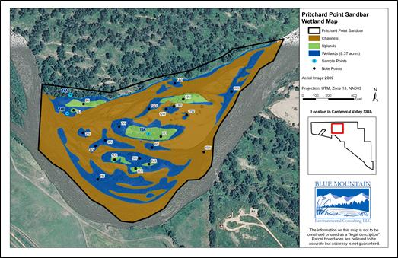
Riverine wetlands along the South Platte River may be considered a naturally occurring atypical situation as unvegetated channels (brown areas above) meet ACOE wetland criteria.

Gelvin Ranch Phase I Environmental Site Assessment
Project Services
- Phase I Environmental Assessment in accordance with ASTM E-1527-05
- Interviews
- Site Reconnaissance
- Interior Observations
- Exterior Observations
- Government Records Review
- Report Preparation
- GIS Mapping & Database Development

Client
Mike Higuera
The Nature Conservancy
2424 Spruce Street
Boulder, CO 80302
720-914-7045

Timeframe
October 2010 – November 2010

Contract Value
$4,300

Yuma County, CO

Gelvin Ranch is a 920-acre working ranch located in eastern Yuma County, Colorado. A Phase I Environmental Assessment was initiated because the landowner transferred developmental rights to The Nature Conservancy through a conservation easement.

Based on the results of the Phase I Environmental Site Assessment investigation, we determined that the Gelvin Ranch property was free of environmental hazards and contamination. A trash dump was observed near the western property boundary in an eroded drainage ditch; however, the site was examined and believed to be de minimus, as containers were empty and evidence of release, such as distressed vegetation and odors, were not observed. Blue Mountain consulted with Environmental Data Resources, Inc. of Milford, Conn., to obtain available environmental records data to help identify recognizable environmental conditions on and surrounding the property.

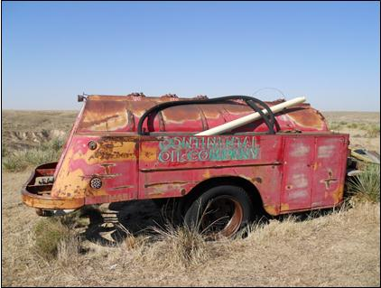
A historic Continental Oil Company truck found on the Gelvin Ranch that was examined and determined to be de minimus of toxic/hazardous chemical release.

Ladder Livestock (CAP) Grazing Plan
Project Services
- Conservation Activity Plan (CAP) Grazing Plan in per NRCS 528 guidelines
- Resource and Forage Inventories
- Forage Animal Balance
- Rotational Grazing Plan
- Contingency Plan
- Ecological Range Site Mapping
- GIS Mapping & Database Development

Client
Mark Shirley
USDA NRCS
Box 607
Cypress Avenue
Saratoga, WY 82331
307-326-5657

Timeframe
August 2010 –
February 2011

Contract Value
$17,500

Carbon County, Wyoming, Routt and Moffat Counties, CO

Ladder Livestock is a large and complicated transhumance operation in north-central Colorado and south-central Wyoming that operates on over 140,000 deeded or leased acres. Blue Mountain worked in conjunction with the ranch operators and the local Natural Resource Conservation Service District conservationist to develop a comprehensive grazing plan for the operation.

The components of a grazing conservation activity plan are defined by the Natural Resource Conservation Service and include an inventory of ranch infrastructure, forage inventories, estimations of grazing utilization and a rangeland trend evaluation. We used information from these inventories to complete forage balance worksheets and develop a grazing rotation plan that will preserve rangeland condition while meeting animal forage needs. Ecological Range Site maps were developed by evaluating edaphic, topographic and vegetative characteristics per NRCS guidelines to supplement forage descriptions.

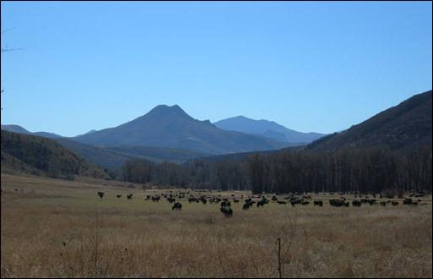
Irrigated pastures and rangelands provide abundant forage for the cattle, horses and sheep that are part of the Ladder Livestock grazing operation.
Bryce Valley Watershed Proper Functioning Condition Assessment
Project Services
- Flow Duration Assessment
- Rosgen Stream Type Evaluation
- Proper Functioning Condition Assessment
- Georeferenced GIS Database Development
- Vegetation Evaluation
- Report Development and Management Recommendations
- Interagency Collaboration

Client
Shane Green
USDA NRCS
125 S. State Street
#4418
Salt Lake City, UT 84138
801-524-4567

Timeframe
August 2009 - May 2010

Contract Value
$39,000

Garfield County, UT

Blue Mountain was contracted by the Natural Resource Conservation Service to conduct a watershed assessment. The intent of the effort was to gather resource information about the physical structure and biological function of five rivers, to prioritize treatment areas and to develop management recommendations.

Blue Muontain assessed sixty-five miles of waterways including portions of the Paria River, Little Creek, Yellow Creek, Henderson Creek and Henrieville Creek. We conducted field assessments that included flow duration, Rosgen stream classification and a proper functioning condition evaluation (per BLM TR 1737-15 guidelines). Waterways in this part of the country are characterized by flashy flows and correspondingly high sediment transport and deposition. Lotic conditions in this system were further confounded by historical disturbances, contemporary land use, water depletions and augmentations. Project findings identified areas that were in proper functioning condition and prioritized the treatment of areas that were rated functional-at-risk or non-functional. Recommendations were made and baseline conditions were established in a geo-referenced database to support future management activities. This project involved collaboration with NRCS, BLM, NPS, USGS and private landowners.
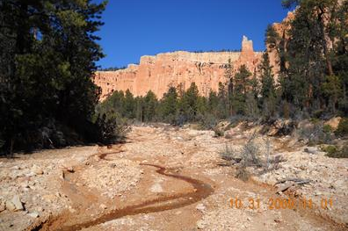

Yellow Creek, which originates in Bryce Canyon National Park, is characterized by flashy flows and high sediment transport.
Poudre River Riparian Forest Assessment
Project Services
- Developed Custom Field Techniques
- Literature Review
- Riparian Forest Assessment

Client
Rick Bachand
City of Fort Collins
Natural Areas Program
1745 Hoffman Mill Rd.
Fort Collins, CO 80522
970-415-2183

Timeframe
April 2009 - July 2009

Contract Value
$5,250
Larimer County, CO

Blue Mountain was contracted by the City of Fort Collins Natural Areas Program to conduct a riparian forest inventory on approximately 15 miles of the Poudre River.

The goal of this study was to quantify the distribution, composition and abundance of tree species growing in the riparian corridor. We used fixed-width, variable-length belt transects to assess basal area by species. Abundance was recorded for desirable species such as narrowleaf and plains cottonwood and mulberry along with the abundance of undesirable species such as crack willow, Russian olive, tamarisk, Siberian elm and others. Regeneration less than 1” diameter at breast height was evaluated and used in conjunction with diameter distribution data to determine trends in regeneration.
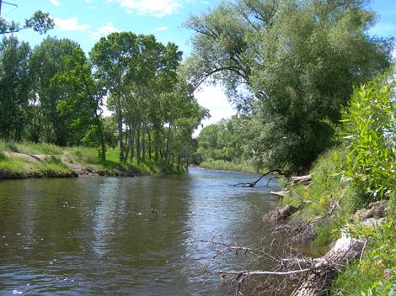

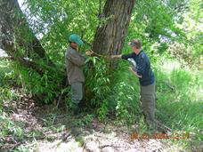
Winterhaven Conservation Easement Baseline Report
Project Services
- Conservation Easement Baseline Report Preparation
- GIS Map & Database Development
- Noxious weed inventory
- MLRA Review
- Riparian Area Proper Functioning Condition Assessment

Client
Matt Reddy
Ducks Unlimited
One Waterfowl Way
Memphis, TN 38120
970-381-2876

Timeframe
April 2009 - May 2009

Contract Value
$3,500

Sedgewick County, CO

The Winterhaven property is an 820-acre working ranch located in northeast Colorado along the South Platte River. The property was purchased by Ducks Unlimited in 2009 to protect conservation values and restore waterfowl habitat.

This property has high habitat potential because it is along a major flyway and is proximal to other protected lands with wetland and upland habitats. Our baseline documentation report went beyond the requirements of Internal Revenue Service for charitable contributions to include a noxious weed inventory and management plan, evaluation of riparian condition to establish baseline conditions and Major Land Use Area reports to establish historical rangeland composition. A comprehensive GIS database was developed to quantify site resources to support future management activities.

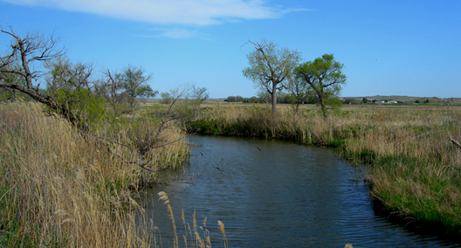
The Winterhaven property has numerous ox bows that are associated with the South Platte River. These wetlands provide valuable resting and foraging habitat for diverse waterfowl species.
Legacy Land Trust Conservation Values (GIS) Model
Project Services
- GIS Database Development and Modeling
- Obtained relevant spatial data for modeling processed (preliminary layers)
- Training and technical support
- Report Development

Client
Jane Clark
Legacy Land Trust
214 S. College Ave.
Fort Collins, CO 80524
970-266-1711

Timeframe
Fall 2008 - Spring 2009

Contract Value
$7,700
Larimer, Jackson and Weld Counties, CO

Blue Mountain was contracted by Legacy Land Trust to develop a Conservation Values Model. This conservation values model was developed in a Geographic Information System (GIS) database to identify places within Larimer, Jackson and Weld counties where conservation values are represented on the landscape.

Conservation values were broken into ecological, agricultural and scenic categories. In order to incorporate these values into the GIS project, available data layers were researched, compiled, weighted, analyzed and filtered. The ecological category was comprised of the Colorado Division of Wildlife Riparian Habitat Map, the Colorado Partners Map and Colorado Natural Heritage Program Potential Conservation Areas Map. Agricultural values were obtained from USGS SSURGO database and included prime soils and soils of statewide significance. Scenic values included scenic byways and polygons designated by Legacy Land Trust. Preliminary output maps were filtered with COMap to identify private lands where Legacy Land Trust can implement projects. In a separate modeling process, projected urban growth within the project area was utilized to identify where urban growth will be likely to occur near areas that represent conservation values. The primary modeling output and preliminary data layers are illustrated below.

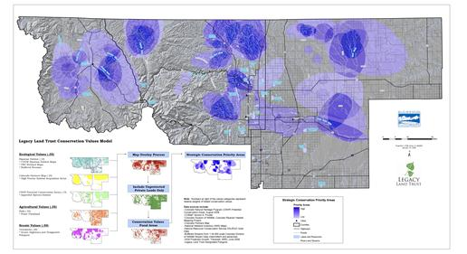

North Sterling State Park Stewardship Plan
Project Services
- Vegetation Inventory and Condition Assessment
- Rare Plant Survey
- Georeferenced GIS Database Development
- Wildlife Habitat Survey
- Comprehensive Park Stewardship Plan Development

Client
Rob Billerbeck
Colorado State Parks
1313 Sherman Street
Denver, CO 80203
303-866-3203

Timeframe
August 2008 - May 2009

Contract Value
$16,000

Logan County, CO

Blue Mountain collaborated with Colorado State Parks to develop a new stewardship plan for North Sterling State Park. The new stewardship plan will guide park management for the next 10 to 15 years.

The 4,970-acre park provides diverse recreational opportunities, including hunting and fishing, boating and camping, for visitors to the eastern plains of Colorado. To meet park stewardship goals, our team worked closely with park staff to assess resource conditions and integrate projected uses into a new stewardship plan. In compliance with State Park conventions, this report addressed resource element descriptions, resource influences such as recreational use and reservoir levels, recommendations and resource monitoring.

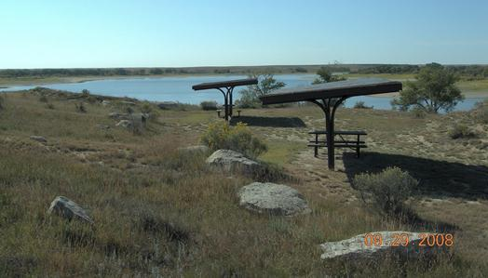
Development of the North Sterling State Park Stewardship Plan involved balancing resource conditions with current and anticipated resource demands and constraints.

Kenosha Ponds Wetland Reclamation
Project Services
- Site Reclamation Oversight
- Grade Surveying
- Project Facilitation
- Wetland Reclamation Technical Assistance
- Minor Grade Adjustments

Client
Boulder County Parks
and Open Space
5201 St. Vrain Road
Longmont, CO 80503
303-678-6205

Timeframe
March 2007 -
September 2007

Contract Value
$16,000

Boulder County, CO

Boulder County Parks and Open Space contracted Blue Mountain to assist with the implementation of a gravel mine reclamation plan at their 100-acre Kenosha Ponds property.

The site was mined for gravel by a local contractor for five years. We provided a reclamation plan that included grading to support a variety of wetland community types in the bottom of the pit. Blue Mountain worked closely with the mining company and county to ensure that plan objectives were met, provided technical advice, facilitated the project and implemented changes as the project evolved.
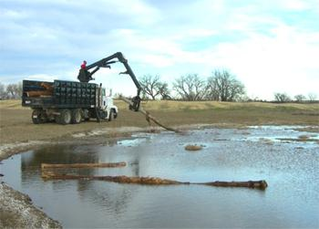



Blue Mountain used a D5 bulldozer to refine the final grade of wetland contours to prevent shoreline erosion. Our team also contracted with a local arboriculture company to obtain coarse woody debris to create wildlife habitat and improve soil structure.

Saddle Pocket Ranch Conservation Easement Baseline Report
Project Services
- Conservation Easement Baseline Report Preparation
- GIS Database Development
- Client Advocate

Client
Bick Marsh
Saddle Pocket Ranch
77568 CR 129
Slater, CO 81653
970-690-1610

Timeframe
September 2007 -
December 2007

Contract Value
$3,500

Routt County, CO

Saddle Pocket Ranch is a 1,003-acre cattle ranch located in Routt County, Colorado, just east of Slater on the Colorado-Wyoming border.

Originally purchased in 1881, this ranch has remained in the same family for more than 127 years. In order to continue their ranching legacy, the client chose to enroll this property in a conservation easement, which reduces their tax burden and protects it from future development. Blue Mountain worked closely with the property owner and land trust to develop a baseline report that was reflective of their management objectives and addressed their concerns in this legal transaction. A comprehensive GIS database was developed to quantify site resources to support future ranching activities.
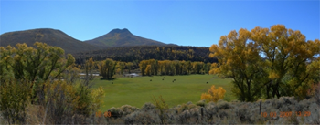

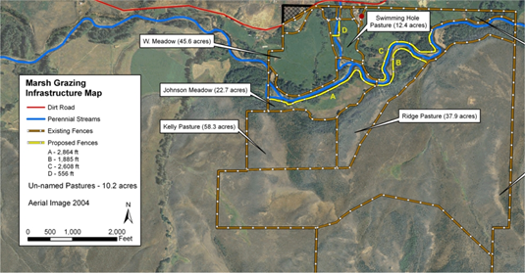

GIS maps expedited plan review and will support future ranching activities.

Project Services
- Rare Plant Survey
- Raptor Survey
- EIS Alternative Development
- Public Meetings
- Resource Reports

Client
Bill Nelson
Larimer County Emergency Services
2501 Midpoint Drive
Ft. Collins, CO 80525

Subcontractor to:
Mangi Environmental
7915 Jones Branch Dr.
Suite 2300
McLean, VA 22102
703-760-4801

Timeframe
May 2007 -
December 2007 & Spring 2012

Contract Value
$20,000

Bald Mountain Communications Facility NEPA Assessment

Larimer County, CO

Blue Mountain assisted Mangi Environmental Group in NEPA planning and oversight for the development of a communications tower on USFS land in Larimer County.

The Bald Mountain Environmental Assessment was conducted to evaluate the impacts of the proposed project and its alternatives. Blue Mountain conducted resource assessments that included a rare plant survey, raptor survey, vegetation assessment and a sedimentation assessment of project roads. Project alternatives were developed in conjunction with Mangi Environmental, Larimer County and USFS personnel. Resource reports were prepared per USFS guidelines in the spring of 2012.

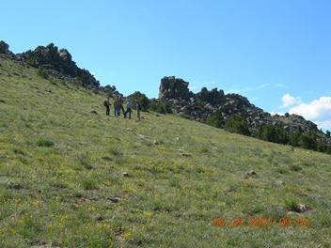
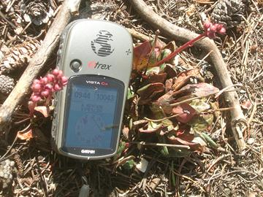
The project team develops project alternatives at the summit of Bald Mountain (top). A rare moonwart was found in the rare plant survey (bottom).

Castle Pines Ecosystem Management Plan
Project Services
- Forest Restoration
- Wildfire Mitigation
- Landscape Arboriculture Management
- Noxious Weed Inventory & Management
- Erosion and Sedimentation Evaluation

Client
Rod Moraga
Anchor Point Group
3775 Iris Ave. Suite2A
Boulder, CO 80301
303-665-FIRE

Timeframe
March 2007 -
August 2007

Contract Value
$15,000

Douglas County, CO

Blue Mountain and the Anchor Point Group were contracted to develop a comprehensive ecosystem management plan for the Castle Pines Homeowners Association.

Castle Pines is a 1,000-acre covenant-protected community and former Colorado home of the Professional Golf Association Tour where the property-wide real estate value exceeds $12.7 billion.

The Castle Pines Ecosystem Management Plan was created in conjunction with a Community Wildfire Protection Program to meet long-range resource planning goals for open space, to mitigate the risk of wildfire, to ensure that management activities are ecologically sustainable and to integrate these directives with social preferences.

The natural environment at Castle Pines intermingles with residential developments, golf courses, roads, trails and site infrastructure. These site conditions presented special challenges and opportunities for management. For example, golf greens establish fuel brakes throughout the community but these areas are irrigated with recycled waste water. Salts and ions dissolved in this water source caused decline of ponderosa pine trees in and adjacent to fairways. As a result, our forest management recommendations were expanded to address the use of recycled waste water and arboricultural issues associated with landscaping. Likewise the noxious weed assessment identified erosion and sedimentation as a major cause for weed propagation. Unstable sites such as cut banks, water ways, ditches and construction areas were common throughout the property. These early seral environments are ideal locations for weed establishment and dispersal. Our prioritized and species-specific noxious weed management recommendations were accompanied by erosion and sedimentation guidelines and restoration seed mixes.


Gypsum Creek Restoration & Enhancement
Project Services
- Installation of Bio-technical Stream Stabilization Practices

Client
Wagner Kelley
Colorado Erosion
Control
26944 Weld CR 15
Loveland, CO 80537
970-744-8061

Timeframe
March 2006 - June 2006

Contract Value
$6,000

Eagle County, CO

Walsh Environmental contracted Colorado Erosion Control and Blue Mountain to implement bio-technical stream stabilization practices on the Gypsum Creek in Eagle County, Colorado.

Blue Mountain implemented restoration practices to create offset acres for a 404 permit associated with the Brightwater residential development. Coyote willow stands were established along approximately one mile of Gypsum Creek. This early seral native shrub was chosen because it promotes bank stabilization and soil development. Live stakes were harvested from natural stands in the area prior to leaf germination in the spring. These stems were subsequently chilled and soaked in water for several days. Stakes were installed by pinning or with a portable water jet.
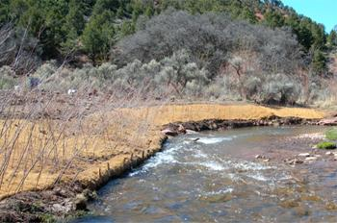
Coyote willow stands were established to stabilize stream banks. Live stakes were installed through erosion mats (left) or as a brush mattress (below). Live stakes must be installed days before leaf development to ensure survival.
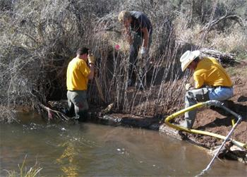
National Center for Atmospheric Research Ecosystem Management Plan
Project Services
- Forest Restoration
- Wildfire Mitigation
- GIS Database Development
- Wildlife Inventory & Management
- Forest & Vegetative Inventory
- Noxious Weed Inventory & Management
- Management Plan Development

Client
Operations Department
1850 Table Mesa Dr.
Boulder, CO 80305
303-497-1000

Timeframe
May 2005 -
September 2005

Contract Value
$10,000

Boulder County, CO

Blue Mountain and the Anchor Point Group were contracted to develop a comprehensive planning document for the 450-acre National Center for Atmospheric Research reserve. This plan was created to meet long-range resource planning goals for open space, to ensure that management activities are ecologically sustainable and to integrate these goals with social directives.

Blue Mountain met these objectives through the implementation of an ecosystem management planning process that included field inventories, database searches, literature reviews and Geographic Information System (GIS) mapping. Anchor Point Group provided technical assistance with wildfire behavior modeling and the development of restoration prescriptions. Project Envelope, an ERSI ArcMap extension, was utilized to distribute plots across stratifications. Vegetation composition was evaluated with Modified Whittaker Intensive plots to quantify species composition and abundance while noxious weed populations were mapped in accordance with North American Invasive Plant Mapping Standards. A custom weed control plan and spatially explicit map was subsequently created. The final report was well-referenced and written for the public to garner support for the project.
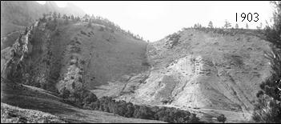

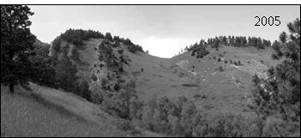
Repeat photography demonstrates changes to forest structure.
Poudre River Restoration
Project Services
- Installation of Bio-technical Stream Stabilization Practices

Client
Crystal Strauss
City of Ft. Collins
1745 Hoffman Mill Rd,
Ft Collins, CO 80524
970-416-2815

Timeframe
March 2005 - July 2005

Contract Value
$4,000
Larimer County, CO

Blue Mountain aided Colorado Erosion Control in the implementation of biotechnical stream stabilization practices on the Poudre River in Fort Collins, Colorado.

We designed restoration practices to stabilize slopes and create a range of vegetative communities between the river’s edge and adjacent uplands. The project incorporated three vegetative zones, each with specific seed mixes and erosion control practices that were based on slope and proximity to flowing water. Coyote willow stands were established along the stream corridor; live stakes were harvested from natural stands in the area prior to leaf germination in the spring. These stems were subsequently chilled and soaked in water for several days. Habitat trees (snags) were also incorporated into the final restoration.

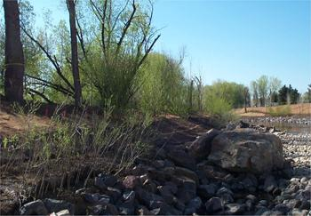

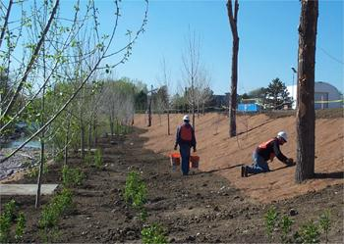

Site restoration incorporated three vegetative zones along the river’s edge. A variety of erosion control blankets were used based on slope and proximity to flowing water.
Button Rock Watershed Stewardship Plan
Project Services
- Forest Restoration
- Wildfire Mitigation
- GIS Database
- Wildlife, Forest, Vegetation & Noxious Weed Inventory
- Management Plan Development

Client
Dennis Fisher
City of Longmont
1100 S. Sherman St.
Longmont, CO 80501
303-823-6060

Timeframe
March 2003 -
August 2003

Contract Value
$5,000
City of Longmont, CO

Blue Mountain was contracted to develop a comprehensive planning document for the Button Rock Preserve, a 3,000-acre property located west of Lyons, Colorado.

The property contains the Longmont and Ralph Price reservoirs, which supply drinking water to the City of Longmont; as such, the primary goals were forest restoration and wildfire mitigation to reduce the risk of catastrophic wildfire and the associated post-fire impacts on the water-supply system. In addition, the City needed an integrated weed-management plan and species inventory of plant and animal diversity.

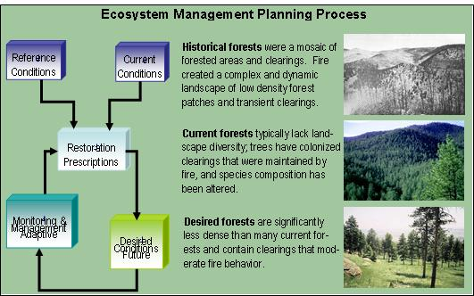
Blue Mountain met these objectives through the implementation of an ecosystem management planning process that included field inventories, database searches, literature reviews and Geographic Information System (GIS) mapping. Anchor Point Group provided technical assistance with wildfire behavior modeling and the development of restoration prescriptions. Noxious weed populations were mapped in accordance with North American Invasive Plant Mapping Standards and a custom weed control plan was subsequently created. An implementation schedule was generated to outline project components and facilitate management efforts.

Genesee Foundation Ecosystem Management Plan
Project Services
- Forest Restoration & Wildfire Mitigation
- GIS Database Development
- Riparian Assessment & Management
- Forest, Vegetative, and Noxious Weed Inventory & Management
- Public Outreach and Education

Client
Ryan Babcock
Genesee Foundation
24425 W. Currant Dr.
Golden, CO 80401
303-526-9463

Timeframe
Numerous Projects
2003 - 2009

Contract Value
$5,000 to $16,000

Jefferson County, CO

Blue Mountain and Anchor Point Group were contracted to develop a comprehensive ecosystem management plan for the Genesee Foundation. This plan provided long-term planning for open space resources and provided background information about local natural resources.

Genesee is a 1,000-acre covenant-protected community where the developed environment coexists with the area's natural setting.

Blue Mountain created the Genesee Ecosystem Management Plan to meet long-range resource planning goals for open space, to ensure ecosystem sustainability and to integrate these directives with community preferences. Specific project goals were to enhance and maintain native plant and animal species, their communities and the ecological processes that sustain them; restore forest health and reduce the risk of catastrophic wildfire to the forest and community; develop an integrated management approach that encompasses all ecological communities represented at Genesee; and provide a tool for Genesee residents to understand the complexity of the Genesee ecosystem.

Anchor Point Group completed a comprehensive wildfire risk assessment that included a community assessment and wildfire behavior modeling to identify values at risk.

