FEDERAL SUPPLY SERVICE AUTHORIZED FEDERAL SUPPLY SERVICE PRICE LIST

Schedule 899 -5 & 899-5RC: Professional Service Schedule Contract Period: 4/06/09 - 4/05/19
Contract Number: GS-10F-0134V

Turtle Wings, Inc. (dba Data Killers) is an R2, E-steward, ISO certified, HUBzone company with MD MBE/DBE certification. Founded in 2005 and based in Maryland, we provide the following services:
•• Electronics recycling with complete asset management tracking capabilities (We pick up and recycle all computers, monitors, printers, copiers, mainframes, telecom equipment, hubs, stereos, cell phones, keyboards, and misc. electronics)
•• Certified destruction by shredding or incineration of any types of materials. In keeping with our environmental mission, all incineration takes place in state-of-the-art waste to energy facilities.
•• Data destruction services nationwide-both on-site and off-site destruction of all media (We perform purging; shredding; crushing; degaussing of all media)
•• De-installations of data centers, telecom centers, all types of electronics, and central offices.
We are certified by the Defense Logistics Information Service to store and transport military critical technical data.
We are proposing to provide services under the following SINs:
- 899-5 - Reclamation, Recycling, and Disposal
  - Electronics Recycling
  - Data Destruction
  - Incineration
  - Shredding
- 899-5RC – Award Disaster and Recovery

TURTLE WINGS, Inc.
Dba Data Killers
4721 Boston Way Lanham, MD 20706
Telephone: 301-583-8399 I Fax: 443-346-0208
info@turtlewings.com
zack@turtlewings.com
www.TURTLEWI NGS.com www.DATAKI LLERS.com

Contract Number: GS-10F-0134V
Period Covered by Contract: 4/06/09 - 4/05/2019 Pricelist current through 4/05/2019
Contract Administration Contact: Zack Boorstein

On-line access to contract ordering information, terms and conditions, up-to-date pricing, and the option to create an electronic delivery order are available through GSA Advantage!, a menu-driven database system. The Internet address for GSA Advantage! is http://www.GSAAdvantage.gov. Agencies can also browse GSA Advantage! By accessing the Federal Supply Service's Home Page via the Internet at http://www.fss.gsa.gov/
CUSTOM ER INFOR MATION
1a. PRICING TABLE

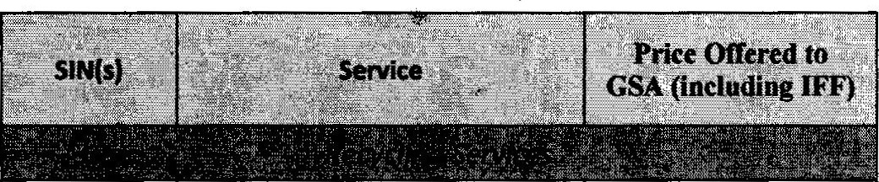


'-
899-5Computers
899-5Monitors - CRT
899-5Monitors -LCD
899-5Servers and Laptops
$2.27
. $18.64
$2.27
$4.48
899-5Printers/Scanners/Faxes
899-5Switches/Hubs
899-5Large Printers
899-5Floor Model Copiers
899-5Server Cabinets
$2.27
$2.27
$7.05
$19.14
$9.57
899-5
$2.27
899-5
899-5
899-5
899-5
Back-up Batteries (UPS)
File-size Box of Assorted Electronics
Misc. Metal Objects Misc. Plastic Items
Serial Number Scan
$2.27
$0.23
$0.38
$0.96
Certificate of Recycling (1
899-5included per job)
$1.76
Removal of hard drive
899-5from device
899-5DVD of destruction
$4.03
$22.92
Offsite Wiping(contractor
899-5site)
$11.08
899-5Onsite Wiping (gov. site)
$11.08
Wiping Device Set-Up
899-5and Rental (Gov. site)
$151.13
Certificate of Destruction
899-5(1included per job)
$1.76
899-5

899-5
Basic Logistic Charge**
Additional Labor Charge***
$115.87
$39.80
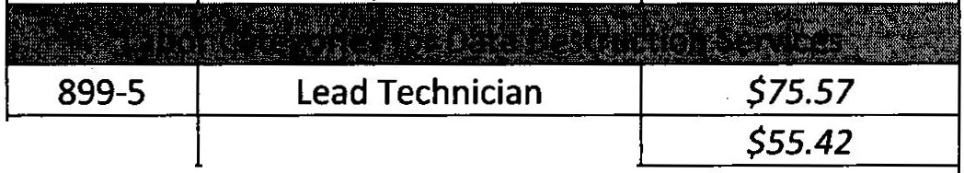
899-5
Technician
Basic Logistic Charge** hourly rate includes one truck
driver, medium and one truck driver, light and one 18' truck

Additional Labor Charge*** is for an additional "light" truck driver

899-5 | Witnessed Incineration of Media | $0.35
 | Witnessed Incineration of
899-5 | Standard Products (i.e. clothing, shoes, etc.) | $0.35

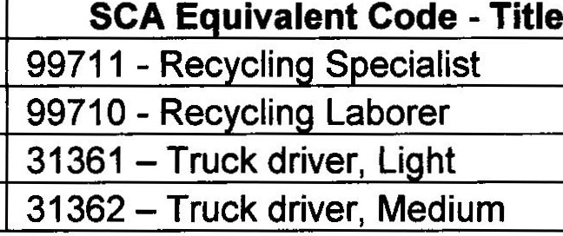
SCA Eligible Contract
Labor Categoy Lead Technician Technician
Truck Driver, Li ht
Truck Driver, Medium
WO Number
05-2103
05-2103
05-2103
05-2103

The Service Contract Act (SCA) is applicable to this contract and it includes SCA applicable labor categories. The prices for the indicated SCA labor categories meet or exceed the requirements of the U.S. Department of Labor Wage Determination Number identified in the matrix. The prices are based on the preponderance of where work is anticipated to be performed and should the contractor perform in an area with lower SCA rates, resulting in lower wages being paid the task order prices will be discounted accordingly.
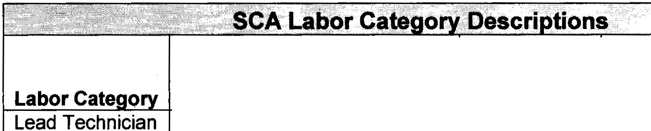
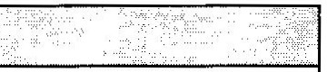

 | Functional Duties I  Responsibilities | Minimum Education Level | Minimum Experience Requirements
 | Leads and oversees on-site data destruction process. Sets up and operates data destruction equipment such as shredder, crusher, wiping device, and degausser. Scans serial numbers and performs inventory. Provides signature on chain of custody paperwork and Certificates as requested. Removes residual material. | GED | 3 years with degaussing, wiping, and shredding  equipment
Technician | Assists lead technician in on- site data destruction process. Assists with the setup and operation of data destruction equipment such as shredder, crusher, wiping device, and degausser. Scans serial numbers and performs inventory. Removes residual material. | GED | 1 year with degaussing, wiping, and shredding  equipment
Truck Driver, Light | Picks up and delivers items from customer site or data destruction facility. Drives trucks ranging in size up to 18 feet. | GED
Truck Driver, Medium | Picks up and delivers items from customer site or data destruction facility. Drives trucks ranging in size up to 26 feet. | GED | Clean driving record, 1 year experience

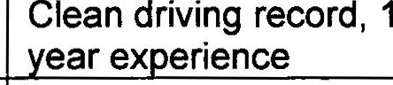
- Maximum order: The Contractor is not obligated to honor any order for a combination of items in excess of these amounts:
ITEM NUMBER/SIN MAXIMUM ORDER All $INS $1,000.000.00

- Minimum order: The minimum dollar value of orders to be issued is $100.00.

- Geographic coverage (delivery area):

Domestic delivery is delivery within the 48 contiguous states, Alaska, Hawaii, Puerto Rico, Washington, DC, and U.S. Territories. Domestic delivery also includes a port or consolidation point, within the aforementioned areas, for orders received from overseas activities.
Overseas delivery is delivery to points outside of the 48 contiguous states, Washington, DC, Alaska, Hawaii, Puerto Rico, and U.S. Territories.

Offerors are requested to check one of the following boxes:

[ ] The Geographic Scope of Contract will be domestic and overseas delivery.
[ ] The Geographic Scope of Contract will be overseas delivery only.
[X] The Geographic Scope of Contract will be domestic delivery only.

- Point of production: Capitol Heights, MD, USA

- Business Size : SMALL

- Discount from list prices or statement of net price: 11.76% - 40%

- Quantity discounts: None
- Prompt payment terms: None, Net 30 days

- Notification that Government purchase cards are accepted at or below the micro purchase threshold and at or above the micro-purchase threshold:

Credit cards will be acceptable for payments below the micro-purchase threshold.
Credit cards will be acceptable for payments above the micro-purchase threshold.

- Foreign items (list items by country of origin): None

11a. Time of delivery: Specified on the task order

11b. Expedited Delivery: All items are available for expedited delivery; however, this must be discussed at time of order placement and depends on size and nature of order.

11c. Overnight and 2-day delivery: All items are available for overnight and two-day delivery; however, this must be discussed at time of order placement and depends on size and nature of order - additional fees may apply.

11d. Urgent Requirements: When the Federal Supply Schedule contract delivery period does not meet the bona fide urgent delivery requirements of an ordering activity, ordering activities are encouraged, if time permits, to contact the Contractor for the purpose of obtaining accelerated delivery. The Contractor shall reply to the inquiry within 3 workdays after receipt. (Telephonic replies shall be confirmed by the Contractor in writing.) If the Contractor offers an accelerated delivery time acceptable to the ordering activity, any order(s) placed pursuant to the agreed upon accelerated delivery time frame shall be delivered within this shorter delivery time and in accordance with all other terms and conditions of the
Contract. Contact Contractor

12. F.O.B. point: Origin

13a. Ordering address:

1771 Olive Street
Capitol Heights, MD 20743

13b. Ordering information telephone number: 301-583-8399

13c. Ordering procedures: For supplies and services, the ordering procedures, information on Blanket Purchase Agreements (BPA's) are found in Federal Acquisition Regulation (FAR) 8.405-3.

14. Payment address:
4721 Boston Way
Lanham, MD 20706

15.
Warranty provision: Contractor's standard commercial warranty

'--·
16.

17.

18.

19.

20a.

20b.

21.

22.

23.

24a.

24b.
Export packing charges: N/A

Terms and conditions of Government purchase card acceptance (any thresholds above the micro-purchase level): N/A

Terms and conditions of rental, maintenance, and repair: N/A Terms and conditions of installation: N/A
Terms and conditions of repair parts indicating date of parts price lists and any discounts from list prices: N/A

Terms and conditions for any other services: N/A List of service and distribution points: NIA
List of participating dealers: N/A Preventive maintenance: NIA
Special attributes such as environmental attributes (e.g. Recycled content, energy efficiency, and/or reduced pollutants): N/A

If applicable, indicate that Section 508 compliance information is available on Electronic and Information Technology (EIT) supplies and services ·and show

 |  | Where full details can be found (e.g. contractor's website or other location.) The EIT standards can be found at: www.Section508.gov/: N/A
 | 25. | Data Universal Number System (DUNS) number: 19-0154505
 | 26. | Contractor's Taxpayer Identification Number (TIN): 20-2295010
 | 27. | Notification regarding registration in Central Contractor Registration (CCR) database:

Contractor has registered with the SAM/Central Contractor Registration Database.

\...

