SKM Industries, Inc.
GSA TERMS AND CONDITIONS
GENERAL SERVICES ADMINISTRATION
Federal Supply Service
Authorized Federal Supply Schedule Terms and Conditions

Please visit https://www.gsaadvantage.gov to view current contract terms and conditions, ordering information and pricing.
Worldwide Federal Supply Schedule Contract for FSC Group 75
Office Products / Supplies and Services and New Product Technology

GSA Contract Number:
GS-14F-1210H
Contract End Date: February 26, 2010

Contract Administration:
SKM Industries, Inc.
41 Catamaran Dr.
Lake St. Louis, MO 63367
Website: http://www.skmproducts.com/
Phone: (636) 625-2932
Fax: (636) 625-6667
email: eposeal@eposeal.com
Business Types/Grants
23 - Minority Owned Business
2X - For-Profit Organization
A2 - Woman Owned Business
FR - Asian-Pacific American Owned
MF - Manufacturer of Goods
VN – Contracts
DUNS: 809108459
CAGE CODE: 1WNK0
Information for Ordering Activities:
1a. Table of awarded special item number: 75-200 – Office Products
1b. Identification of the lowest priced model number and lowest unit price for that model for each special item number awarded in the contract. This price is the Government price based on a unit of one, exclusive of any quantity/dollar volume, prompt payment, or any other concession affecting price. Those contracts that have unit prices based on the geographic location of the customer, should show the range of the lowest price, and cite the areas to which the prices apply. Please see Schedule GS-14F-1210H at www.gsaadvantage.gov
1c. If hourly rates are not applicable, indicate “Not applicable” for this item: Not Applicable.
2. Maximum order: $150,000.
3. Minimum order: $50.00.
4. Geographic coverage (delivery area): The Contiguous 48 States and the District of Columbia. No delivery to Alaska, Hawaii, or Puerto Rico.
5. Point(s) of production: Olyphant, PA; Lake St. Louis, MO
6. Discount from list prices or statement of net price: Prices shown are net, discount has been deducted. Please see Schedule GS-14F-1210H at www.gsaadvantage.gov
7. Quantity discounts: Please Contact SKM Industries, Inc. at (800) 851-8464.
8. Prompt payment terms. Net 30
9a. Government purchase cards are accepted at or below the micro-purchase threshold: Government purchase cards are accepted for orders at or below the micro-purchase threshold.
9b. Notification whether Government purchase cards are accepted or not accepted above the micro-purchase threshold: Government purchase cards are accepted for orders above the micro-purchase threshold.
10. Foreign items (list items by country of origin): SKM Industries, Inc. only offers items that are made in TAA compliant countries.
11a. Time of delivery: Office Products: 1–3 days
Office Furniture: 1-5 days
11b. Expedited Delivery: Available upon request for in stock items.
11c. Overnight and 2-day delivery: Yes

11d. Urgent Requirements. Please contact SKM Industries, Inc. customer service.
12. F.O.B. point(s): Destination
13a. Ordering address:
SKM Industries, Inc.
41 Catamaran Dr.
Lake St. Louis, MO 63367
Website: http://www.skmproducts.com/
Phone: 1-(636) 625-2932
Fax: (636) 625-6667
13b. Ordering procedures: For supplies and services, the ordering procedures, information on Blanket Purchase Agreements (BPA’s), and a sample BPA can be found at the GSA/FSS Schedule homepage (fss.gsa.gov/schedules).
14. Payment address:
SKM Industries, Inc.
1012 Underwood Rd.
Olyphant, PA 18447
Phone: 1-(800) 851-8464
15. Warranty provision: 90 day warranty against defects.
16. Export packing charges, if applicable: Not applicable
17. Terms and conditions of Government purchase card acceptance: Government Credit Cards are accepted.
18. Terms and conditions of rental, maintenance, and repair (if applicable): Not Applicable.
19. Terms and conditions of installation (if applicable): Not Applicable.
20. Terms and conditions of repair parts indicating date of parts price lists and any discounts from list prices (if applicable): Not Applicable
20a. Terms and conditions for any other services (if applicable): Not Applicable.

21. List of service and distribution points (if applicable):
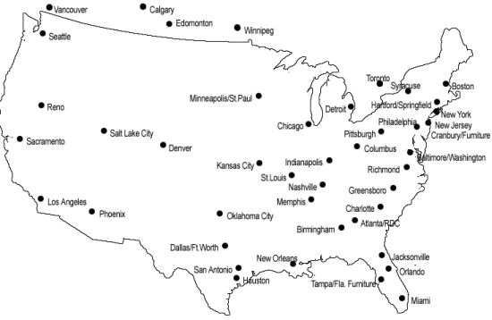
22. List of participating dealers (if applicable): Not Applicable.
23. Preventive maintenance (if applicable): Not Applicable.
24a. Special attributes such as environmental attributes (e.g., recycled content, energy efficiency, and/or reduced pollutants): SKM Industries, Inc. is compliant and offers paper products up to 30% recycled content.
24b. If applicable, indicate that Section 508 compliance information is available on Electronic and Information Technology (EIT) supplies and services and show where full details can be found (e.g. contractor’s website or other location.) The EIT standards can be found at: www.Section508.gov/: Not Applicable.
25. Data Universal Number System (DUNS) number: 809108459
26. Notification regarding registration in Central Contractor Registration (CCR) database: Sun Supply, Inc. is registered on the Central Contractor Registration (CCR) database, www.ccr.gov. CCR Cage Number: 1WNK0

Business type: Small, Woman Owned Business
Please Contact Us with Any Questions.
Thank you for choosing SKM Industries, Inc.!

