General Services Administration
Federal Supply Service Authorized Federal Supply Schedule Price List

On-line access to contract ordering information, terms and conditions, up-to-date pricing, and the option to create an electronic delivery order area available through GSA Advantage!, a menu-driven database system. The INTERNET address GSA Advantage! is: GSAAdvantage.gov
SCHEDULE TITLE, and FSC Group 03FAC, Facilities Maintenance
FSC CLASS: Services CONTRACT NUMBER: GS-21F-0053V
CONTRACT PERIOD: March 11, 2009 – March 10, 2014
CONTRACTOR’S NAME, ADDRESS, TELEPHONE AND FAX NUMBER; EMAIL AND WEB SITE ADDRESS:
Marine Engine Maintenance, Inc. 259100 Canal Road Suite 0 #112 Orange Beach, Al 36561-5016 Telephone No: 757-342-9010 FAX No: 757-224-1956
Email: MarineEngine@cox.net
Website: www.87engines.com
CONTRACTOR’S ADMINISTRATION SOURCE: Kevin R Simpson
BUSINESS SIZE: Small Business, Veteran’s Service Disabled

INFORMATION FOR ORDERING ACTIVITIES:
1a TABLE OF AWARDED SPECIAL ITEM NUMBERS (SIN): 812-02 Dockside Maintenance and Repair Services
1b. The price lists shown below are for the contract period commencing March 11, 2009 through March 10, 2014. The company costs have been applied to the hourly rate and are shown for information purposes.
COMPANY COSTS ON EACH LABOR HOUR |  |  |  |  | PARTS AND MATERIALS WILL BE CHARGED AT INVOICE COST PLUS THE COMPANY COSTS BASED ON THE SCOPE OF WORK ORDERED BY THE AGENCY
General and Administration | 20% | The offered prices to GSA are the Burden Rates which include all G & A, Overhead and Profit. The hourly labor rates are provided for straight and overtime per the requirements of the solicitation. Saturdays are time and one half. Federal Holidays and Sundays are double time. |  |  | General and Administration |  |  | 20%
Overhead | 25% |  |  |  | Overhead |  |  | 25%
Profit | 15% |  |  |  | Profit |  |  | 15%
Pricing CY 2009
LABOR CATEGORY | LABOR RATE/HOUR STRAIGHT | BURDEN RATE/HOUR STRAIGHT | STRAIGHT RATE DISCOUNTED 3% | LABOR RATE/HOUR OVERTIME | BURDEN RATE/HOUR OVERTIME | OVERTIME RATE DISCOUNTED 3%
Senior Certified Diesel Mechanic Technician | $93.75 | $150.00 | $145.50 | $140.63 | $225.00 | $218.25
Certified Diesel Mechanic | $93.75 | $150.00 | $145.50 | $140.63 | $225.00 | $218.25
Welder | $46.88 | $75.00 | $72.75 | $70.31 | $112.50 | $109.13
General Laborer | $31.25 | $50.00 | $48.50 | $46.88 | $75.00 | $72.75

Pricing CY 2010
LABOR CATEGORY | LABOR RATE/HOUR STRAIGHT | BURDEN RATE/HOUR STRAIGHT | STRAIGHT RATE DISCOUNTED 3% | LABOR RATE/HOUR OVERTIME | BURDEN RATE/HOUR OVERTIME | OVERTIME RATE DISCOUNTED 3%
Senior Certified Diesel Mechanic Technician | $101.25 | $162.00 | $157.14 | $151.88 | $243.00 | $235.71
Certified Diesel Mechanic | $101.25 | $162.00 | $157.14 | $151.88 | $243.00 | $235.71
Welder | $50.63 | $81.00 | $78.57 | $75.94 | $121.50 | $117.86
General Laborer | $33.75 | $54.00 | $52.38 | $50.63 | $81.00 | $78.57
Pricing CY 2011
LABOR CATEGORY | LABOR RATE/HOUR STRAIGHT | BURDEN RATE/HOUR STRAIGHT | STRAIGHT RATE DISCOUNTED 3% | LABOR RATE/HOUR OVERTIME | BURDEN RATE/HOUR OVERTIME | OVERTIME RATE DISCOUNTED 3%
Senior Certified Diesel Mechanic Technician | $109.35 | $174.96 | $169.71 | $164.03 | $262.44 | $254.57
Certified Diesel Mechanic | $109.35 | $174.96 | $169.71 | $164.03 | $262.44 | $254.57
Welder | $54.68 | $87.48 | $84.86 | $82.01 | $131.22 | $127.28
General Laborer | $36.45 | $58.32 | $56.57 | $54.68 | $87.48 | $84.86

Pricing CY 2012
LABOR CATEGORY | LABOR RATE/HOUR STRAIGHT | BURDEN RATE/HOUR STRAIGHT | STRAIGHT RATE DISCOUNTED 3% | LABOR RATE/HOUR OVERTIME | BURDEN RATE/HOUR OVERTIME | OVERTIME RATE DISCOUNTED 3%
Senior Certified Diesel Mechanic Technician | $118.10 | $188.96 | $183.29 | $177.15 | $283.44 | $274.93
Certified Diesel Mechanic | $118.10 | $188.96 | $183.29 | $177.15 | $283.44 | $274.93
Welder | $59.05 | $94.48 | $91.64 | $88.57 | $141.72 | $137.47
General Laborer | $39.37 | $62.99 | $61.10 | $59.05 | $94.48 | $91.64
Pricing CY 2013
LABOR CATEGORY | LABOR RATE/HOUR STRAIGHT | BURDEN RATE/HOUR STRAIGHT | STRAIGHT RATE DISCOUNTED 3% | LABOR RATE/HOUR OVERTIME | BURDEN RATE/HOUR OVERTIME | OVERTIME RATE DISCOUNTED 3%
Senior Certified Diesel Mechanic Technician | $127.55 | $204.07 | $197.95 | $191.32 | $306.11 | $296.93
Certified Diesel Mechanic | $127.55 | $204.07 | $197.95 | $191.32 | $306.11 | $296.93
Welder | $63.77 | $102.04 | $98.98 | $95.66 | $153.06 | $148.46
General Laborer | $42.52 | $68.02 | $65.98 | $63.77 | $102.04 | $98.98

1c. Senior Certified Diesel Mechanic – A mechanic that specializes in overhaul and repair of diesel driven engines. Mechanic has been documented to be certified to work on particular engine manufacturers. Engines are sophisticated including computer software and associated special wiring. Diesel mechanic analyzes malfunctions and overhauls to zero hours, or repairs or rebuilds equipment to include all assemblies, subassemblies, electronics and software. Mechanic operates and inspects equipment to identify performance defects. Various equipment is used in the work such as hoists, calibration equipment, hand tools and gauges. Senior Diesel Mechanic supervises and/or directs workers engaged in same or similar work.
Certified Diesel Mechanic – A mechanic that specializes in overhaul and repair of diesel driven engines. Mechanic has been documented to be certified to work on particular engine manufacturers. Engines are sophisticated including computer software and associated special wiring. Diesel mechanic analyzes malfunctions and overhauls to zero hours, or repairs or rebuilds equipment to include all assemblies, subassemblies electronics and software. Mechanic operates and inspects equipment to identify performance defects. Various equipment is used in the work such as hoists, calibration equipment, hand tools and gauges
Welder – The welder welds metal components to fabricate or repair products such as machine parts, motors and generators according to layouts, blueprints or work orders. The welder uses brazing and a variety of arc and gas welding equipment. The employee uses various certified weld processes, performs related tasks such as thermal cutting and grinding, repairs broken or cracked parts, fills holes and increases size of metal parts, positions and clamps together components associated with marine engines and associated platforms. Worker will locate and repair cracks in marine cylinder heads, using inspection equipment and gas torch. Worker must pass employer performance tests required by a weld society such as American Bureau of Shipping.
General Laborer – The laborer performs tasks that require mainly physical abilities and effort involving little specialized skill. However some mechanic knowledge is beneficial. Laborer loads and unloads trucks, moves supplies and materials to proper location by hand truck or other means. Laborer stacks materials for storage, collects refuse and disposes of salvage materials. Laborer may use hand tools when working with a journeyman diesel mechanic.
Education and Experience Requirements –
Each labor classification except General Laborer requires the followings minimum requirements:
1 - Two years of college or an AA degree, and 2 - Five years of relevant, specialized experience.
General Laborer – basic requirements are:
1 - High School Degree, and 2 -Five years of relevant experience.

2 MAXIMUM ORDER: *$750,000
*If the “best value” selection placed your order over the Maximum Order, identified in this catalog/price list, you have an opportunity to obtain a better schedule contract price. Before placing your order, contact the aforementioned contractor for a better price. The contractor may (1) offer a new price for this requirement, (2) offer the lowest price available under this contract, or (3) decline the order. A delivery order that exceeds the maximum order may be placed under the Schedule contract in accordance with FAR 8.404.
3. MINIMUM ORDER: $100
4. GEOGRAPHIC COVERAGE: Domestic
5. POINT(S) OF PRODUCTION: N/A
6. BASIC DISCOUNT: 3%
7. QUANTITY DISCOUNT(S): None
8. PROMPT PAYMNET TERMS: Net 30
9. GOVERNMENT PURCHSE CARD ACCEPTED: Yes (excludes prompt payment discounts)
10. FOREIGN ITEMS: None
11a. TIME OF DELIVERY AFTER RECEIPT OF ORDER (ARO):
Normal: Varies based on the scope of work submitted by the agency request for proposal.
11b. Emergency: Emergency response is generally available within 24 hours of notification that urgency exists. This determination will be based on the Scope of Work provided by the agency at the time of notification.
11c. Expedited: There are not items that are routinely in this category.
11d. Overnight and 2 day delivery: Should documents require overnight or 2 day delivery, these services are available. The agency is to call the contractor for the rates for delivery as they change at the shipper level.
11e. Urgent Requirement: Clause I-FSS-140-B of the contract applies. Agencies can contract contractor’s representative to possible affect a faster delivery.
12. FOB POINT: Destination
13. ORDERING ADDRESS: Same as Contractor
14. PAYMENT ADDRESS: Same as Contractor
15. WARRANTY PROVISION: Standard Commercial Warranty
16. EXPORT PACKING CHARGES: N/A
17. TERMS AND CONDITIONS OF GCCC ACCEPTANCE: (any thresholds above the micro-purchase level)
18. TERMS AND CONDITIONS OF RENTAL, MAINTENANCE, AND REPAIR (IF APPLICABLE): N/A
19. TERMS AND CONDITIONS OF INSTALLATION (IF PPLICABLE): N/A
20. TERMS AND CONDITIONS OF REPAIR PARTS INDICATING DATE OF PARTS PRICE-LISTS AND ANY DISCOUNTS FROM LIST PRICES (IF APPLICABLE): N/A
20a. TERMS AND CONDITIONS FOR ANY OTHER SERVICES: N/A
21. LIST OF SERVICE AND DISTRIBUTION PIONTS: N/A
22. LIST OF PARTICIPATING DEALERS: N/A
23. PREVENTIVE MAINTENANCE: N/A
24. ENVIRONMENTAL ATTRIBUTES, e.g. RECYCLED CONTENT, ENERGY EFFICIENCY, AND/OR REDUCED POLLUTANTS: Contractor will complete based on each agency Scope of Work.
25. DATA UNIVERSAL NUMBER SYSTEM (DUNS) NUMBER: 78395266
26. NOTIFICATION REGARDING REGISTRATION IN CENTRAL CONTRACTOR REGISTRATION (CCR) DATABASE: YES
"Anytime, Anywhere!"
Available 24 hrs a day, 7 days a week
Phone: 757-342-9010
GSA Contract GS-21F-0053V
ksimpson@87engines.com

Marine Engine Maintenance, Inc. has been awarded GSA Contract No: GS-21F-0053V for Dockside Maintenance and Repair Services SIN 812-002. Marine Engine Maintenance, Inc. is fully dedicated to providing quality technical advice and service to the marine industry. The company provides Factory Trained and Certified (M3, E4) MTU 396 Series Technician with over 8 years experience on MTU's and 27 years experience on diesel engines.
Our services include:
Electronic Troubleshooting Preventive Maintenance and Repairs W5 and W6 MTU Engine Maintenance Inconel Shielding 24-Hour Emergency Service ODR Repair Rebuilding Injector Nozzles Y19 Cable assembly Generator Repair and Installation Display Installation Hydraulic Hose Renewal Reconditioning of Heads
REBUILDS: Raw Water Pump Rebuild Jacket Water Pump Rebuild Turbocharger Rebuild
If you don't see what you need, call us at 757-342-9010.

Background
Marine Engine Maintenance, Inc (MEM, Inc) is a Veteran Service Disabled owned company established in 1989. The company possesses experience in the marine engine, marine electrical and marine electronics business. The president and owner of MEM, Inc, is a retired Senior Chief USCG possessing 27 years of experience in marine engine, engine electrical and engine electronics maintenance, overhaul and repair.
MEM, Inc. is an emerging small business for NAICS codes 336611 and 811310 and a small business for 541990. The last three years the company has successfully repaired and maintained the USCG fleet of 87 CPB vessels in the Atlantic and Pacific. MEM, Inc. currently has an IDIQ contract with US Coast Guard, MLC Pacific with a potential contract value of $2,707,597.77. The contract is for major top end maintenance every six years or 7000 engine hours and emergency response on an as needed basis. MEM, Inc is mobile. The company possesses two trucks and one forty-four foot trailer. The trailer fully encloses the workshop. The company has all tools and equipment necessary to fulfill all work described in this proposal. The maintenance and repair work is performed by a staff of 3 technicians which the company employs. Each possesses a minimum of five (5) years experience and at least two (2) years of college. When additional personnel are required, as a result of work obtained by the company, additional personnel are hired for the individual project. A list of suitable personnel is maintained by the company. The company possesses a fully factory trained technician to include Electrical level 4 (E4) and Mechanical level 3 (M3) for the Motoren Und Turbin Union (MTU) 396 series engines. Copies of the certificates for MTU are attached to this brochure, to illustrate the training of the technicians. MEM, Inc. has successfully been awarded contracts and simplified acquisitions from the US Coast Guard as provided in the past performance portion of this brochure. The company continues to obtain relevant training and experience through communications with MTU, Cummins, Detroit Diesel and other engine manufacturers. Through these training experiences, access to proprietary information is obtained and maintained.
MEM, Inc. manages its accounting processes and the awarded contracts utilizing Quickbooks accounting and estimating software to track all expenditures and inventory. When GFE is provided, the parts are received, observed for condition, checked against the established parts list for the engine under contract, and a GFE document is mutually signed by the U. S. Government and MEM, Inc. If there are any discrepancies in GFE, the company provides a condition found report (CFR) to the agency for its action.
PAST PERFORMANCE –
Marine Engine Maintenance, Inc. encourages agencies to contact our clients to discuss our capabilities and customer service.
U.S. Coast Guard Pacific POC Valerie Rivera-Chase Phone No: 510-637-5972 Contract No: HSCG85-07-D-625143 Project: IDIQ for dockside Maintenance of the Motor turbine Union (MTU) Main engine Operations W5 on various 87 foot Patrol Boats located in the Pacific. Value: $2,707,597
U.S. Coast Guard Pacific (U.S.C.G. PIKE) POC Gilbert Hernandez or MKC Waggoner Phone No: 510-637-5972 Purchase Order No: HSCG85-P-625864 Project: Troubleshooting and repairing of electronic Casualty on Main Diesel engine (MDE #2) Value: $5,050.00
U.S. Coast Guard Pacific (U.S.C.G. Sockeye) POC: Valerie Rivera-Chase Phone No: 510-637-5972 Purchase Order No: HSCG85-08-J-625C25 Project: Overhaul MDE Value: $181,815.00
FACILITIES AND EQUIPMENT
Marine Engine Maintenance, Inc. (MEM, Inc.) is totally mobile. The fully contained shops are enclosed within a forty four (44) foot trailer. Also used are two trucks for GFE and other related work needs. In 2008, MEM, Inc. acquired new stationary facilities in Orange Beach, AL. This facility will provide expanded capability to perform certified testing and other large engine projects.

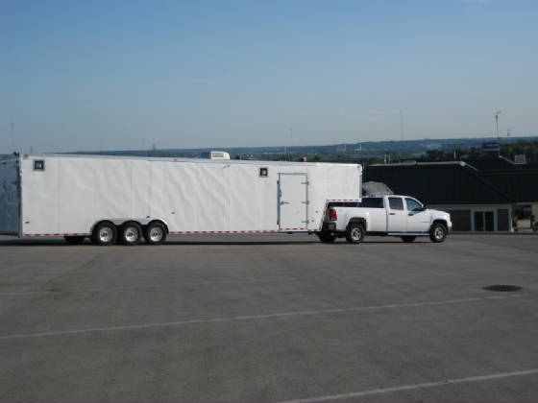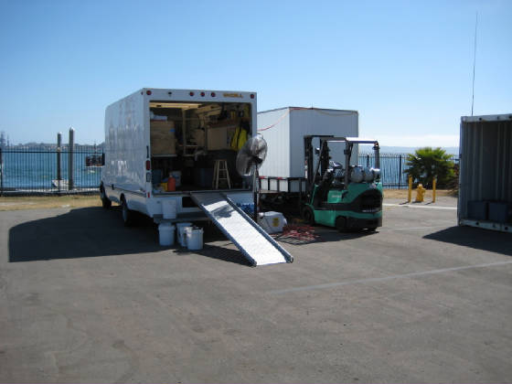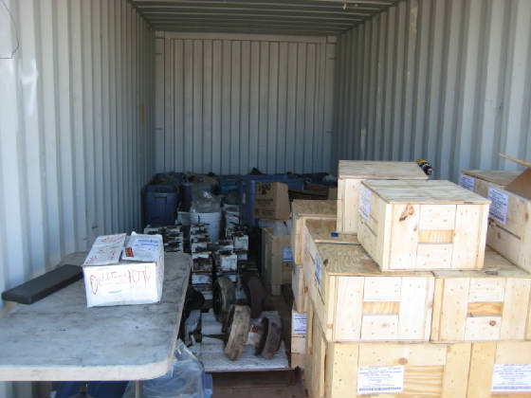
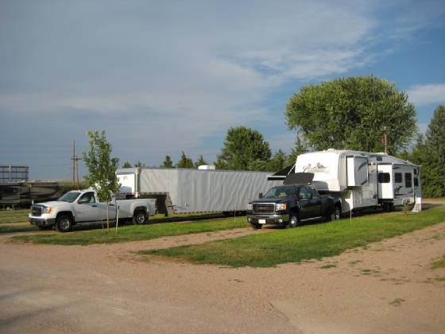
CERTIFIED TRAINING CERTIFICATES
Provided are copies of the training certificates for Kevin Simpson in relation to MTU engines.
