
Minuteman Trucks, Inc.
(800) 225-4808
www.MinutemanTrucks.com

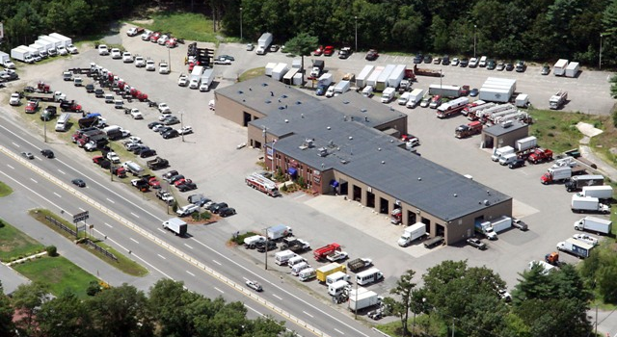

About Us:
Minuteman Trucks, Inc. is a complete medium and heavy-duty truck support center. We are a Commercial Truck dealership for new and used trucks classes 4-8, an authorized franchised parts dealer for Ford, Caterpillar, Cummins, Detroit Diesel, and Daimler Trucks North America, LLC (manufacturer of Sterling and Western Star). We are also the sole Pierce and Medtec Fire & Rescue Apparatus dealer in New England. Our goal is to make sure that each of our customers receives the quality service that we have built our name on.

Certified Minority Business Enterprise (MBE):
- New England Minority Supplier Development Council (NEMSDC) certified MBE
- State Office of Minority & Women Business Assistance (SOMWBA) certified MBE
- Awarded the 2008 Regional Minority Supplier/Distributer of the Year by The U.S. Department of Commerce Minority Business Development Agency (MBDA)

General Services Administration
Authorized Federal Supply Schedule Price List (next page)
General Services Administration
Authorized Federal Supply Schedule Price List

On-line access to contract ordering information, terms and conditions, up-to-date pricing, and
the option to create an electronic delivery order are available through GSA Advantage! ®, a menu-driven database system. The internet address is: www.GSAAdvantage.gov

Schedule 23V Vehicle Multiple Award Schedule
FSC Group 25 – Vehicular Equipment Components

Contract Number: GS-30-F-0023U

For more information on ordering from Federal Supply Schedules click on the FSS Schedules button at www.fss.gsa.gov

Period Covered by Contract: July 11, 2008 through July 11, 2013

MINUTEMAN TRUCKS, INC.
2181 Providence Highway
Walpole, MA 02081
(508) 668 3112
Toll free: (800)-225-4808
www.MinutemanTrucks.com

Modification # 0017 – October 2012

Business Size: Small Business

Customer Information
1a. | Special Item Number: 271-108
1b. | For Awarded Pricing see GSA Advantage
2. | Maximum Order Limitation: $15,000
3. | Minimum Order FOB Destination: $10
4. | Geographic Coverage (delivery area): Continental USA
5. | Point(s) of Production: USA – various locations
6. | Discount from List Prices or Statement of Net Price: 32.7% to 60.4%
7. | Quantity Discounts: None
8. | Prompt Payment Terms: No special discount is offered for prompt payment. Payment terms are net 30 days.
9a. | Government purchase cards are accepted at or below the micro-purchase threshold
9b | Government purchase cards are accepted above the micro-purchase threshold.
10. | Foreign Items (list items by country of origin): None
11a. | Time of Delivery: 14 days ARO
11b. | Expedited Delivery: 3 days ARO
11c. | Overnight and 2-day Delivery: Not Applicable
11d. | Urgent Requirements: When the Federal Supply Schedule contract delivery period does not meet the bona fide urgent delivery requirements of an ordering agency, agencies are encouraged, if time permits, to contact the Contractor for the purpose of obtaining accelerated delivery. The Contractor shall reply to the inquiry within 3 workdays after receipt. (Telephonic replies shall be confirmed by the Contractor in writing.) If the Contractor offers an accelerated delivery time acceptable to the ordering agency, any order(s) placed pursuant to the agreed upon accelerated delivery time frame shall be delivered within this shorter delivery time and in accordance with all other terms and conditions of the contract.
12. | F.O.B. Point(s): 2181 Providence Highway, Walpole, MA 02081
13a. | Ordering Address: Minuteman Trucks, Inc. 2181 Providence Highway, Walpole, MA 02081
13b. | Ordering Procedures: For supplies and services, the ordering procedures, information on Blanket Purchase Agreements (BPA's) and a sample BPA can be found at the GSA/FSS Schedule homepage (fss.gsa.gov/schedules).
14. | Payment Address: Minuteman Trucks, Inc. 2181 Providence Highway, Walpole, MA 02081
15. | Warranty Provision: Manufacturer’s Standard Warranty 1 Year
16. | Export Packing Charges: Not Applicable
17. | Terms and Conditions of Government Commercial Credit Card Acceptance: Agree
18. | Terms and Conditions of Rental, Maintenance & Repair: Not Applicable
19. | Terms and Conditions of Installation: Not Applicable
20. | Terms and Conditions of Repair Parts: Not Applicable
20a. | Terms and Conditions for Any Other Services: Not Applicable
21 | List of Service and Distribution Points: Not Applicable
22 | List of Participating Dealers: Not Applicable
23. | Preventive Maintenance: Not Applicable
24a. | Special Attributes: Not Applicable
24b. | Section 508 Compliance: The Electronic and Information Technology (EIT) standard can be found at www.section508.gov: Not Applicable
25. | Data Universal Number System (DUNS) Number: 097454821
26. | Notification regarding registration in Central Contractor Registration (CCR) database: Yes
27. | Uncompensated Overtime Policy: Not Applicable

