AUTHORIZED FEDERAL SUPPLY SERVICE
FSC Group 23, Part V, Vehicular Multiple Award Schedule (VMAS)
Price List
SPECIAL ITEM NUMBERS: 272-101 Construction Equipment Attachments
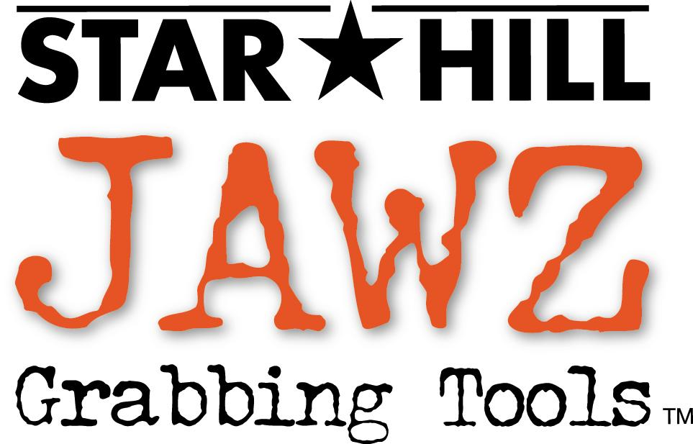

Star Hill Solutions, Inc. dba Star Hill Jawz
895 Main St
Half Moon Bay, CA 94019-2117

Contact: Robert C. Herrick
Telephone: 650-726-2706
Fax: 650-726-2498
Toll Free Number: 877-798-JAWZ (5299)

Internet: http://www.StarHillJawz.com/

CONTRACT NUMBER: GS-30F-0031T

PERIOD COVERED BY CONTRACT: CURRENT THROUGH SEPTEMBER 16, 2012
Modification # 4

GENERAL SERVICES ADMINISTRATION
FEDERAL SUPPLY SERVICE

Products and ordering information in this Authorized FSS Information Technology Schedule Pricelist are also available on the
GSA Advantage! System. Agencies can browse GSA Advantage! by accessing the Federal Supply Service’s Home Page via the
Internet at http://www.fss.gsa.gov/

“Prices Shown Herein are Net (discount deducted)”
Star Hill Solutions, Inc. is a Small Business

1a. Awarded Special Item Numbers: 272-101 Construction Equipment Attachments

1b. See Page 11 for items lowest government price and model numbers.

1c. Not Applicable

2. Maximum Order: SIN 272-101 $200,000.00
3. Minimum Order: SIN 272-101 $100.00
4. Geographic Coverage: CONUS (the 48 contiguous states) and the District of Columbia
5. Points of Production: United States
6. Discounts: Prices Shown Herein are Net (20% discount already deducted)
7. Quantity Discounts: Yes See page 12
8. Prompt Payment Terms: Net 30 Days
9a. Government purchase cards are accepted at or below the micro-purchase threshold.
9b. Government purchase cards are accepted above the micro-purchase threshold.
10. Foreign Items: Country of Origin – United States
11a. Time of Delivery: SIN 272-101 90 Days ARO
11b. Expedited Delivery: 15 to 30 Days ARO
11c. Overnight and 2-day Delivery: Not Available
11d. Urgent Requirements: When the Federal Supply Schedule contract delivery period does not meet the bona fide urgent delivery requirements of an ordering agency, agencies are encouraged, if time permits, to contact the Contractor for the purpose of obtaining accelerated delivery. The Contractor shall reply to the inquiry within 3 workdays after receipt. (Telephonic replies shall be confirmed by the Contractor in writing.) If the Contractor offers an accelerated delivery time acceptable to the ordering agency, any order(s) placed pursuant to the agreed upon accelerated delivery time frame shall be delivered within this shorter delivery time and in accordance with all other terms and conditions of the contract.

12. F.O.B. Point: Destination – CONUS (the 48 contiguous states) and the
District of Columbia

13a. Ordering Address:

Star Hill Solutions, Inc. dba Star Hill Jawz
895 Main St
Half Moon Bay, CA 94019-2117
Phone: 650-726-2706
Fax: 650-726-2498
Toll Free: 877-798-JAWZ (5299)

Ordering Procedures: For supplies and services, the ordering procedures, information on Blanket Purchase Agreements (BPA’s), and a sample BPA can be found at the GSA/FSS Schedule homepage (www.fss.gsa.gov/schedules ).

14. Payment Address:

Star Hill Solutions, Inc. dba Star Hill Jawz
895 Main St
Half Moon Bay, CA 94019-2117
Phone: 650-726-2706
Fax: 650-726-2498
Toll Free: 877-798-JAWZ (5299)

15. Warranty Provisions: Standard Commercial Warranty – See Page 12

16. Export Packing: Overseas shipping and export packing is not included in this
contract.

17. Terms and Conditions of Government Purchase Card Acceptance: See 9a and 9b above.

18. Terms and Conditions of Rental, Maintenance, and Repair: Not Applicable
19. Terms and Conditions of Installation: Not Applicable
20. Terms and Conditions of Repair Parts: Not Applicable
21. List of Service and Distribution Points:

Star Hill Solutions, Inc. dba Star Hill Jawz
895 Main St
Half Moon Bay, CA 94019-2117
Phone: 650-726-2706
Fax: 650-726-2498
Toll Free: 877-798-JAWZ (5299)

22. List of Participating Dealers See Para. 13a above

23. Preventive Maintenance: Not Applicable
24a. Special Attributes such as environmental: None
24b. Section 508 Compliance: Not Applicable
25. Data Universal Number System (DUNS) Number: 154156496
26. Registration in Central Contractor Registration (CCR) database:
Yes – Star Hill Solutions Inc. is registered with CCR CAGE Code 3YMD6

Star Hill Jawz Hydraulic Grabbing Tools
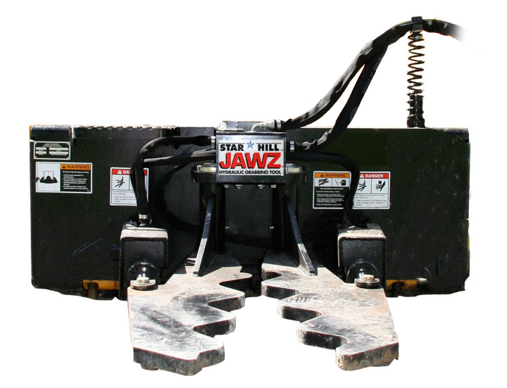

- The patented Star Hill Jawz Grabbing Tools are front-end attachments for land management tasks such as removing invasive trees, fence posts, stakes, and moving large rocks or boulders. The Star Hill Jawz Grabbing Tools are uniquely designed attachments with the Jawz fingers opening on a horizontal plane. This permits the operator to specifically grab anything as small as one inch rebar to large boulders while keeping soil disturbance to a minimum. Wildlife managers including local, state, and federal agencies across the US are utilizing Jawz to remove non-native invasive trees, and brush such as; tamarisk, russian olive, autumn olive, buckthorn, manzanita, scotch broom, honeysuckle, and others. Utilizing the Star Hill Jawz Grabbing Tools is more precise than a grapple, thumb, clamshell or 4 & 1 bucket. It is more efficient than a shear, tree saw, or cutter because it doesn’t leave the roots in the ground. Jawz fingers are made from T-1 steel plate with robust construction throughout.
- There are three versions.
- The Super Jawz, model C3700CQA is made with quick couple system. This version is designed to fit wheel loaders, and medium excavators. The wheel loader version, Model C3700CQA is designed with a quick couple system to accommodate wheel loaders and medium excavators.
- The Standard Jawz, model B2700QA is made with a standard universal quick attach backplate. This version is designed to fit skid steers, track loaders, and tractors. John Deere tractors have a unique quick attach system that we have developed a backplate to match, this model is the same as the B2700QA except for the backplate. This model is the B2700QA-JD.
- The Mini version is a smaller unit called the Mini Jawz model #A1700MQA. This unit is designed for compact utility loaders or mini skid steers with a smaller universal quick attach backplate. Bobcat mini loaders have a unique quick attach system that we have developed a backplate to match, this model is the same as the A1700MQA except for the backplate. This model is the A1700MQA-B.
- Operating Capacity for the Jawz model C3700CQA is 10000lbs.
- Operating Capacity for the Jawz model B2700QA and B2700QA-JD is 3000 lbs.
- Operating Capacity for the Jawz model A1700MQA and A1700MQA-B is 2300 lbs.
- Squeezing force in excess of 6000 pounds at center point of Jawz fingers.
- Made in the USA.
- The Jawz Grabbing Tool is the perfect loader attachment for grabbing and removing invasive trees, shrubs, brush, and hedges, roots and all.
- Easily remove embedded fence posts or t-stakes.
- Easily grab and place large rocks or boulders.
- Enhances operator safety and lessens the chance of injury.
- Increases employee productivity while quickly paying for itself.

Product: SUPER JAWZ GRABBING TOOL FOR WHEEL LOADERS

Mfr Part#: C3700CQA

Mfr: Star Hill Solutions, Inc.
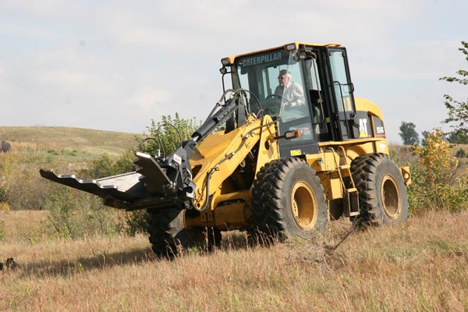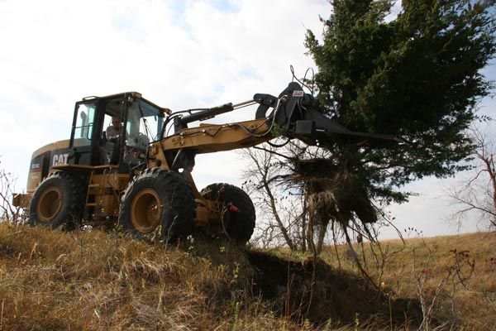

The patented Star Hill Jawz Grabbing Tools are hydraulic front-end attachments for land management chores such as removing invasive trees and brush, fence posts, stakes, and moving large rocks or boulders. The wheel loader version, Model C3700CQA is designed with a quick couple system to accommodate wheel loaders and medium excavators. The Jawz Grabbing Tool is the best wheel loader and excavator attachment for grabbing and removing invasive plants, trees, shrubs and brush, roots and all. Jawz fingers are made from 1.5 inch thick T-1 steel and open on a horizontal plane to 58 inches at the tips with a lifting capacity of 10000 lbs. Jawz is more precise than a grapple, thumb, clamshell or 4 in 1 bucket. It is more efficient than a shear, tree saw or cutter because it doesn’t leave the roots in the ground. Use Jawz for: tamarisk, russian olive, honeysuckle, red cedar, mesquite and buckthorn removal: rock placement, post/stake removal, landscaping, debris clearing and demolition.

Product: JAWZ GRABBING TOOL SKIDSTEER ATTACHMENT

Mfr Part#: B2700QA

Mfr: Star Hill Solutions, Inc.
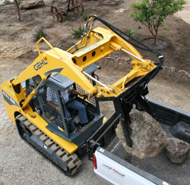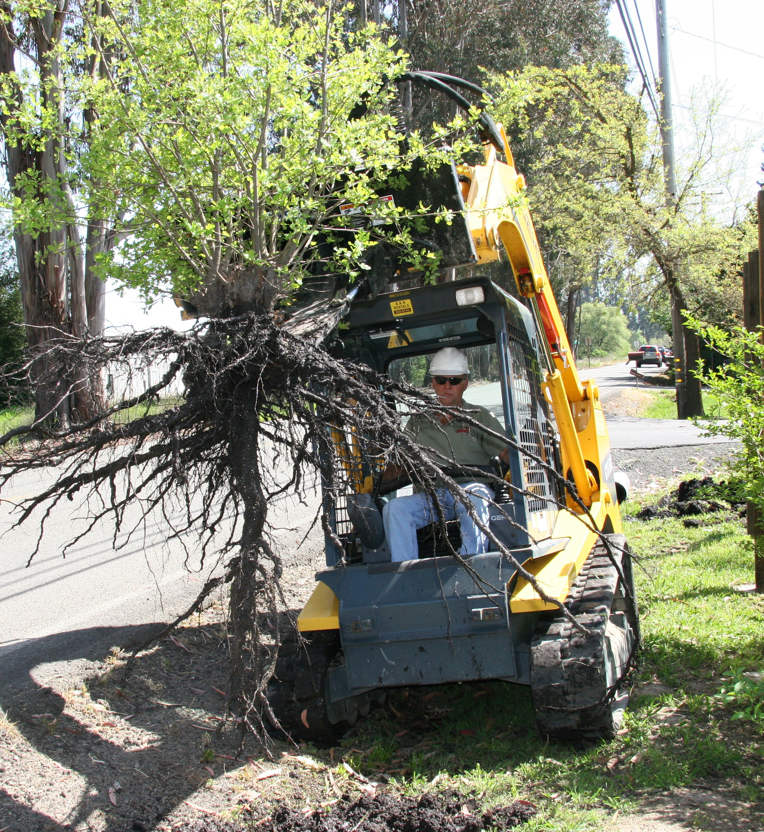

The patented Star Hill Jawz Grabbing Tools are hydraulic front-end attachments for land management such as removing invasive trees and brush, fence posts, stakes, and moving large rocks or boulders. Jawz Grabbing Tool, Model B2700QA is designed with a universal backplate for skid steers, farm tractor loaders, or utility loaders with the standard quick attach systems. The Jawz Grabbing Tool is the smartest skidsteer attachment for grabbing and removing invasive trees, shrubs, brush, and hedges, roots and all. Jawz fingers are 1-inch thick T-1 steel, and open on a horizontal plane to 34 inches at the tips with an operating capacity of 3000lbs. The Grabbing Tool is more precise than a grapple, or 4 & 1 bucket. It is more efficient than a shear, tree saw, or cutter because it doesn’t leave the roots in the ground. This attachment is recommended for these tasks; Tamarisk, Russian olive, honeysuckle, red cedar, buckthorn, rock placement, landscaping tasks, debris clearing, & demolition.

Product: The Jawz Grabbing Tool for John Deere Quick Attach
Mfr Part#: B2700QA-JD
Mfr Star Hill Solutions, Inc.

The patented Star Hill Jawz Grabbing Tools are hydraulic front-end attachments for land management such as removing invasive trees, fence posts, stakes, and moving large rocks or boulders. Jawz Grabbing Tool, Model B2700QA-JD, has a backplate to fit the John Deere quick attach farm tractor loaders. This model is the same as the B2700QA except for the backplate. The Jawz Grabbing Tool is the smartest tractor loader attachment for grabbing and removing invasive trees, shrubs, brush, and hedges, roots and all. The Jawz fingers are 1-inch thick T-1 steel, and open on a horizontal plane to 34 inches at the tips with an operating capacity of 3000lbs. The Grabbing Tool is more precise than a grapple, or 4 & 1 bucket. It is more efficient than a shear, tree saw, or cutter because it doesn’t leave the roots in the ground. This attachment is recommended for these tasks; Tamarisk, Russian olive, honeysuckle, red cedar, buckthorn, rock placement, landscaping, debris clearing & demolition.

Product: MINI JAWZ GRABBING TOOL MINI ATTACHMENT
Mfr Part#: A1700MQA

Mfr: Star Hill Solutions, Inc.

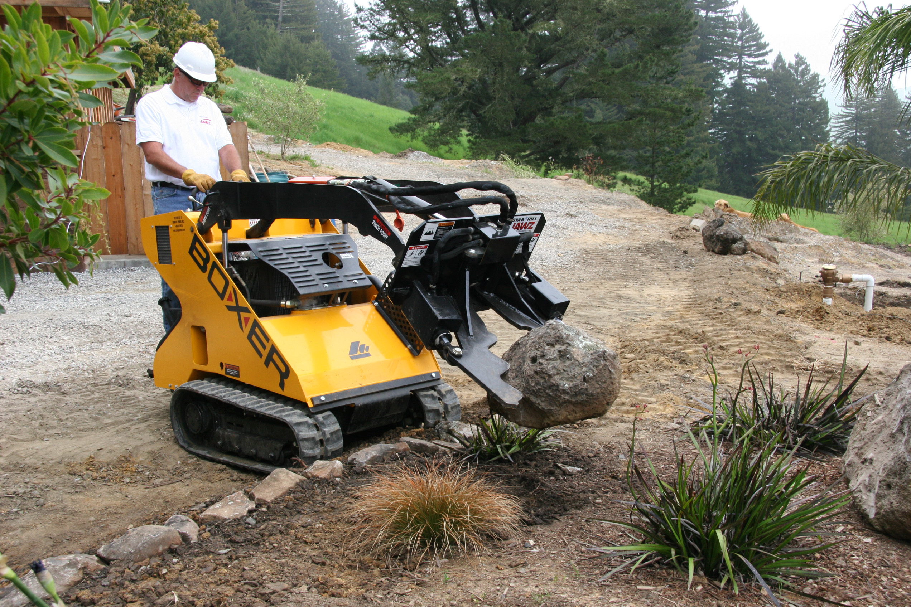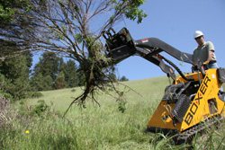

The patented Star Hill Jawz Grabbing Tools are hydraulic front-end attachments for land management tasks such as removing invasive trees and brush, fence posts, stakes, and moving large rocks or boulders. Mini Jawz Grabbing Tool, Model A1700MQA, has a universal mini backplate to fit mini skid steers or compact utility loaders with the mini standard quick attach systems. The Grabbing Tool is the smartest compact utility loader attachment for grabbing and removing invasive trees, shrubs, brush, and hedges, roots and all. Mini Jawz fingers are 0.75-inch thick T-1 steel, and open on a horizontal plane to 26 inches at the tips with an operating capacity of 2300lbs. The Grabbing Tool is more precise than a grapple, or 4 & 1 bucket. It is more efficient than a shear, tree saw, or cutter because it doesn’t leave the roots in the ground. This attachment is recommended for these tasks; Tamarisk, Russian olive, honeysuckle, red cedar, buckthorn, rock placement, landscaping tasks, debris clearing.

MINI JAWZ GRABBING TOOL FOR BOBCAT MINI

Mfr Part #: A1700MQA-B
Mfr: Star Hill Solutions, Inc.
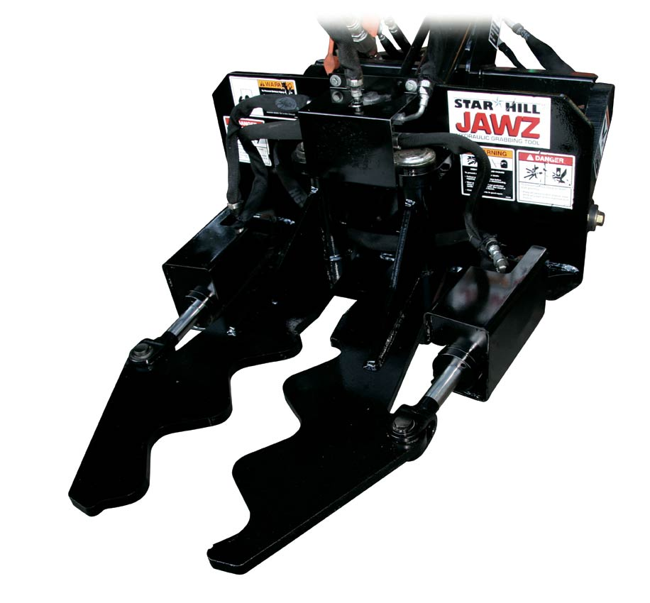
The patented Star Hill Jawz Grabbing Tools are hydraulic front-end attachments for land management tasks such as removing invasive trees or brush, fence posts, stakes, and moving large rocks or boulders. The Mini Jawz Grabbing Tool, Model A1700MQA-B, has a backplate to fit Bobcat mini skid steers or mini loaders with their unique quick attach system. The Jawz Grabbing Tool is the smartest compact utility loader attachment for grabbing and removing invasive trees, shrubs, brush, and hedges, roots and all. Mini Jawz fingers are 0.75-inch thick T-1 steel, and open on a horizontal plane to 26 inches at the tips with an operating capacity of 2300lbs. The Grabbing Tool is more precise than a grapple, or 4 & 1 bucket. It is more efficient than a shear, tree saw, or cutter because it doesn’t leave the roots in the ground. This attachment is recommended for these tasks; Tamarisk, Russian olive, honeysuckle, red cedar, buckthorn, rock placement, landscaping tasks, debris clearing & others.

Price List for Star Hill Jawz Grabbing Tools

Star Hill Solutions, Inc. dba Star Hill Jawz

SIN Part Number Product Description Warranty Origin GSA Price

272-101 A1700MQA Mini Jawz fits universal 12 months US $2520.00
quick attach for Mini Skid
Steers except Bobcat Mini
Skid

272-101 A1700MQA-B Mini Jawz fits universal 12 months US $2520.00
quick attach for Bobcat
Mini Skid Loaders

272-101 B2700QA Jawz Grabbing Tool with 12 months US $3276.00
universal quick attach
mounting backplate

272-101 B2700QA-JD Jawz Grabbing Tool with 12 months US $3276.00 John Deere tractor quick attach
backplate

272-101 C3700CQA Super Jawz Grabbing Tool to fit 12 months US $10624.00
wheel loaders and
medium excavators

Quantity Discounts Schedule
MAXIMUM Upper Limit of Price Range | Potential Units by Model |  |  | Discount | Discounted Prices
MAXIMUM Upper Limit of Price Range | B2700QA | A1700MQA | C3700CQA |  | B2700QA | A1700MQA | C3700CQA
$ 15,000 | 4 | 5 | 1 | 20% | $ 3,276.00 | $ 2,520.00 | $10,624.00
$ 20,000 | 5 | 7 | 1 | 20% | $ 3,276.00 | $ 2,520.00 | $10,624.00
$ 40,000 | 11 | 16 | 3 | 23% | $ 3,153.15 | $ 2,425.50 | $10,225.60
$ 60,000 | 18 | 25 | 6 | 26% | $ 3,030.30 | $ 2,331.00 | $ 9,827.20
$ 80,000 | 25 | 35 | 8 | 29% | $ 2,907.45 | $ 2,236.50 | $ 9,428.80
$ 100,000 | 33 | 46 | 11 | 32% | $ 2,784.60 | $ 2,142.00 | $ 9,030.40
$ 150,000 | 52 | 73 | 17 | 35% | $ 2,661.75 | $ 2,047.50 | $ 8,632.00
$ 200,000 | 72 | 102 | 24 | 38% | $ 2,538.90 | $ 1,953.00 | $ 8,233.60

